Deep Feature Fusion for Robust Demographic Group Classification in Facial Images
Tayaba Anjum^{*1}, Naila Hamid¹
¹ University of Management and Technology, Department of Computer Science, Lahore Campus, Lahore, Pakistan
²University of Management and Technology, Department of Computer Science, Sialkot Campus, Sialkot, Pakistan
Correspondence:
Tayaba Anjum : tayaba.anjum@umt.edu.pk
Article Link: https://www.brainetwork.org/index.php/jcai/article/view/207
DOI: https://doi.org/10.69591/jcai.3.2.5
  Volume 3, Issue 2, 2025  Funding  No  Copyright  The Authors  Licensing  licensed under a Creative Commons Attribution 4.0 International License. | Citation: Anjum, T., Hamid, N., (2026). Deep Feature Fusion for Robust Demographic Group Classification in Facial Images, 3(2), 40-55.  Conflict of Interest: Authors declared no Conflict of Interest  Acknowledgment: No administrative and technical support was taken for this research  Article History Submitted: Sep 02, 2025  Last Revised: Nov 16, 2025  Accepted: Dec 17, 2025    An official Publication of  Beyond Research Advancement & Innovation Network, Islamabad,  Pakistan

Deep Feature Fusion for Robust Demographic Group Classification in Facial Images
Tayaba Anjum^{*1}, Naila Hamid ²

¹University of Management and Technology, Department of Computer Science, Lahore Campus, Lahore, Pakistan

²University of Management and Technology, Department of Computer Science, Sialkot Campus, Sialkot, Pakistan

Abstract
Classifying demographic groups from facial images is challenging because differences between groups can be subtle, while variations in lighting, pose, or expression often dominate the visual signal. To address this, we propose a hybrid deep feature fusion approach that combines two complementary strengths. Faces are first detected and aligned using MTCNN to ensure consistency across samples. We then extract features in two ways: a pretrained CNN captures dataset-specific appearance cues, while FaceNet provides compact embeddings that preserve identity-related information. Instead of relying on either representation alone, we integrate both through a multilayer perceptron classifier, which learns more flexible decision boundaries in the fused space. Experiments on a AsianFaceRace dataset as well as UTKFace and FairFace benchmarks demonstrate that the fusion approach not only improves accuracy but also shows promising cross-dataset generalization compared to single-feature methods. These results highlight the value of combining CNN-derived and embedding-based representations, offering a more robust framework for demographic group classification and fairness-aware face analysis.
Keywords: Race classification, transfer learning, FaceNet, MTCNN, ethnicity classification, deep learning.

Introduction
Classifying demographic groups from facial images is a challenging and socially relevant task in computer vision and biometrics. Facial analysis systems are increasingly used in applications such as identity verification, multimedia analytics, and human–computer interaction [1-3]. However, their performance often varies across demographic groups, raising concerns about robustness, fairness, and potential bias in AI systems [4, 5]. Addressing these challenges requires models that can capture subtle group-specific differences while remaining resilient to variations in pose, illumination, expression, and occlusion [6, 7].
It is important to emphasize that this study does not aim to make claims about inherent differences between demographic groups. Rather, our focus is on developing methods that are technically robust, generalizable, and fairness-aware. All datasets used are publicly available and processed to respect privacy. The goal is to advance methodological approaches—specifically through feature fusion—without drawing social, cultural, or value-based conclusions.
Early approaches to demographic classification relied on handcrafted descriptors such as Local Binary Patterns (LBP) [8], Histograms of Oriented Gradients (HOG) [9], and color histograms, often combined with Support Vector Machines (SVM) [10]. While computationally efficient, these methods struggled with real-world variations and lacked generalization capability. The rise of deep learning brought convolutional neural networks (CNNs) pretrained on large-scale datasets such as ImageNet [11], enabling transfer learning for demographic analysis [12, 13]. More recently, embedding-based pipelines such as FaceNet [14] and ArcFace [15] provided compact, identity-preserving representations that improve recognition robustness. However, embeddings are often used with simple linear classifiers, which may fail to capture complex decision boundaries needed for subtle distinctions between demographic groups.
Despite these advances, two main limitations remain. First, CNN-based transfer learning approaches are highly dataset-dependent and may underperform when applied to images from different sources, such as varying lighting, pose, or camera conditions [13, 15]. Second, embedding-based methods, while generalizable, may overlook dataset-specific visual cues important for accurate classification. Since CNNs and embeddings capture complementary information, combining them in a principled way offers a promising route for more robust and fair demographic analysis. Prior work has shown that fusing features across CNN streams can improve recognition [16], yet few studies systematically combine CNN-derived features with embedding-based representations while explicitly addressing fairness and generalization.
To address this gap, we propose a hybrid feature fusion framework for demographic group classification. Faces are first detected and aligned using MTCNN [17], then features are extracted through two parallel streams: a pretrained CNN backbone (ResNet50) and FaceNet embeddings. These representations are concatenated and fed into a multilayer perceptron (MLP) with nonlinear layers and dropout regularization [18]. By fusing dataset-specific CNN features with generalizable FaceNet embeddings, the model leverages complementary strengths, achieving improved accuracy and cross-dataset robustness.
The main contributions of this study are:
- We introduce a hybrid fusion architecture that integrates CNN features with FaceNet embeddings for demographic classification, improving robustness over single-stream methods.
- We demonstrate that applying an MLP with nonlinear transformations to embeddings outperforms conventional linear classifiers, enhancing generalization.
- We evaluate the approach on custom, UTKFace, and FairFace datasets, including cross-dataset experiments, highlighting improved fairness, generalization, and robustness.
- We provide a complexity analysis, showing that the method is practical for real-world deployment.

Literature Review
Early work in demographic face classification mainly relied on handcrafted features such as Local Binary Patterns (LBP) [8] and Histograms of Oriented Gradients (HOG) [9], often paired with simple classifiers like Support Vector Machines (SVM) [10]. While computationally efficient and interpretable, these methods struggled with variations in lighting, pose, and occlusion [6], and often failed to generalize to diverse populations.
The advent of deep learning, particularly convolutional neural networks (CNNs) such as VGGNet [12] and ResNet [13], introduced more powerful hierarchical features. Pretrained on large datasets like ImageNet [11], these models improved demographic prediction through transfer learning. Nevertheless, CNN-based classifiers can degrade under cross-dataset evaluation due to domain shifts [5], highlighting a lack of robustness in real-world applications.
Embedding-based methods, including FaceNet [14], ArcFace [15], and SphereFace [19], offer compact, identity-preserving representations [7]. They generalize well across datasets but are often coupled with simple linear classifiers, which may be insufficient to capture complex intra-group variations [20]. Accurate face detection and alignment, such as via MTCNN 17], improves reliability by reducing pose and scale variability [22], yet many earlier studies overlooked this step.
Despite the progress in CNNs and embeddings, relatively few works have systematically explored combining these complementary representations. Handcrafted features and CNNs capture dataset-specific patterns, while embeddings preserve identity information and improve generalization. Hybrid approaches that fuse both feature types, especially with nonlinear classifiers, remain underexplored [16, 23]. This gap motivates our study: we propose a hybrid CNN–FaceNet pipeline with a multilayer perceptron (MLP) classifier that explicitly models interactions between heterogeneous features, aiming for more robust and fairer demographic classification.

Table 1: Summary of representative approaches for race and ethnicity classification, highlighting their strengths and limitations.
Approach | Strengths | Limitations
Handcrafted Features (e.g., LBP [8], HOG [9] + SVM/Logistic Regression | Computationally efficient, interpretable; worked reasonably well under controlled settings. | Highly sensitive to pose, illumination, and occlusions; limited representational capacity; poor generalization to real-world datasets.
CNN-based Transfer Learning (e.g., VGG [12], ResNet [13]) | Rich hierarchical features; benefits from large-scale pretraining (ImageNet [11]); effective fine-tuning for ethnicity recognition [20]. | Performance can degrade under cross-dataset testing due to domain shift; requires large, balanced datasets for optimal adaptation.
Embedding-Based Methods (e.g., FaceNet [14], ArcFace [15], SphereFace [19]) | Compact, identity-preserving facial embeddings; strong generalization across datasets; widely adopted in face recognition. | Typically paired with simple linear classifiers; may not capture complex inter-class boundaries; reduced performance under high intra-class diversity.
Face Detection and Alignment (e.g., MTCNN [17]) | Improves consistency of input regions; reduces variability due to pose, scale, and rotation; enhances downstream classification performance [24]. | Often ignored in earlier studies, misalignment or poor detection can propagate errors to feature extraction and classification stages.

Methodology
The proposed framework integrates face detection, feature extraction, and classification into a unified pipeline, as illustrated in Figure 1. Unlike conventional approaches that rely solely on transfer learning CNNs or precomputed embeddings, our method fuses both representations, allowing the classifier to leverage complementary information. This hybrid design aims to increase robustness against intra-class variations such as pose, illumination, and expression, supporting fair and generalizable demographic group classification.
Face Detection and Alignment
Prior to feature extraction, input faces are standardized to minimize acquisition variability. We employ MTCNN [17], which jointly performs face detection and landmark alignment. Key points, such as the eyes, nose, and mouth, are used to warp faces into a canonical orientation. Proper alignment reduces variability due to pose and scale, improving the consistency and performance of downstream classifiers [22, 24].

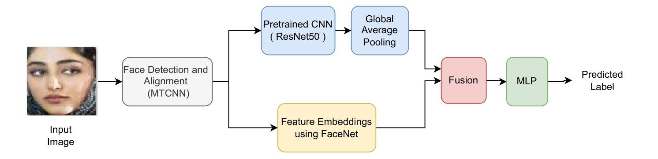
Figure 1: Proposed deep feature fusion framework: faces are aligned with MTCNN, features are extracted in parallel by a CNN backbone and FaceNet, then fused and classified by an MLP for robust demographic group classification.
Feature Extraction Streams
Aligned faces are processed through two parallel feature extraction streams:
CNN Backbone. Pretrained CNNs (e.g., ResNet50 [13], InceptionV3 [25]) extract dataset-specific features. Early layers capture low-level textures, while deeper layers encode abstract patterns. The convolutional base up to the global average pooling layer produces a compact feature vector fcnn ∈ ℝd1 .
FaceNet Embeddings FaceNet [14] maps each face into a 128-dimensional embedding efn ∈ ℝ128 , capturing identity-preserving information. These embeddings complement CNN features by providing robust geometric descriptions of facial structure that are less sensitive to dataset-specific noise.
The combination of these streams balances dataset-specific adaptation from CNNs with generalization from embedding
Feature Fusion and Classification
Feature vectors are concatenated:
h = [fcnn ; efn], (1)
where [;] denotes concatenation. The fused vector $h$ is input to a multilayer perceptron (MLP) with two fully connected layers using ReLU activation and dropout [18], followed by a softmax output layer for multi-class demographic classification:
ŷ = Softmax (W2 σ (W1h + b1) + b2), (2)

where (.) is the ReLU function. The MLP allows the model to capture nonlinear interactions in the fused feature space, supporting robust decision boundaries across subtle inter-group differences.

Results & Discussion
Dataset and Preprocessing
The AsianFaceRace dataset used in this study was introduced in our previous work [26]. It consists of 3,192 facial images collected from online sources, representing a variety of demographic characteristics and facial conditions, including differences in age, gender, pose, and illumination. The images were processed by cropping the face regions and selecting frontal or near-frontal views, followed by resizing them to 224 × 224 pixels. To enhance the model’s ability to generalize to unseen samples, data augmentation techniques such as horizontal flipping, zooming, and brightness variation were applied during the training phase. The details of the training and testing data distribution are provided in Table 2, and representative samples from the dataset are shown in Figure 2.
Table 2. Dataset composition across training and test sets.

Category | Group A (Asian) | GroupB  (Non-Asian) | Total
Training | 1382 | 1725 | 3107
Test | 42 | 43 | 85
Overall | 1424 | 1768 | 3192

Figure 2. Representative facial images illustrating diversity in age, gender, and appearance
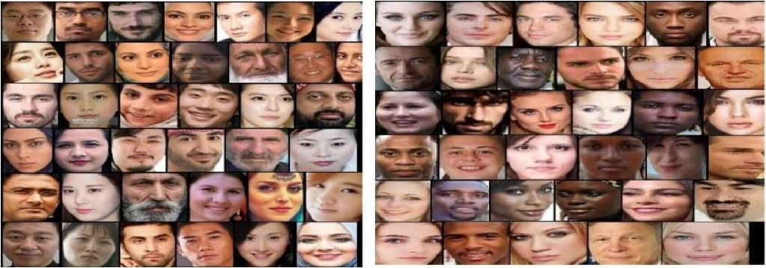
Experimental Setup
This section describes the experiments conducted to evaluate different approaches for race classification using facial images. Traditional transfer learning models trained on raw images were compared with embedding-based methods that use pretrained face recognition models.
- Transfer Learning on CNN Models:
Transfer learning was applied to VGG16, ResNet50, and InceptionV3 pretrained on ImageNet. The original classification head of each model was removed and replaced with a custom head consisting of a Global Average Pooling 2D layer, a Dense layer with 1024 neurons (ReLU), and a final Softmax output layer with two neurons.
Three fine-tuning strategies were evaluated: freezing all pretrained layers, fine-tuning the last four layers, and fine-tuning the last eight layers. Fine-tuning the last eight layers consistently achieved the best performance by balancing adaptation to the target dataset while preserving useful pretrained features. Freezing all layers resulted in underfitting, whereas fine-tuning additional layers increased the risk of overfitting.
- Embedding-Based Approaches
A two-stage pipeline was adopted. First, facial images were detected and aligned using MTCNN to reduce variations in pose, scale, and rotation. Second, facial features were extracted using a pretrained FaceNet (Inception-ResNet-v1) model to generate 128-dimensional embeddings.
Two classifiers were evaluated: Logistic Regression as a linear baseline and the proposed Multilayer Perceptron (MLP) with two fully connected layers (256 and 128 neurons), ReLU activation, and dropout.
- Training Details
All models were trained using the Adam optimizer with a learning rate of 1 × 10⁻⁴. A batch size of four was used due to GPU memory limitations, and each model was trained for 200 epochs. Categorical cross-entropy served as the loss function. Performance was evaluated using accuracy, precision, recall, and F1-score. Experiments were conducted on an NVIDIA Tesla T4 GPU (16 GB VRAM) using TensorFlow/Keras.
- Results and Analysis
Increasing the number of fine-tuned layers generally improved classification performance. ResNet50 achieved the highest CNN accuracy of 90.1% when the last eight layers were fine-tuned. The training and validation curves are shown in Figure 3, while the comparative results are summarized in Table 3.

Table 3: Test Accuracy (%) for Different Model and Fine-Tuning Setups
Model | Frozen (0 layers) | +4 Layers | +8 Layers
VGG16 | 85.2% | 87.6% | 89.3%
ResNet50 | 86.4% | 88.9% | 90.1%
InceptionV3 | 84.9% | 86.7% | 88.5%
Table 4 summarizes the architectural details of the evaluated models. Fine-tuning the last layers of pretrained CNNs allows the models to adapt high-level features to our dataset while preserving general low-level feature extraction. However, embedding-based methods outperform direct fine-tuning by utilizing facial representations pretrained on large-scale face recognition tasks.

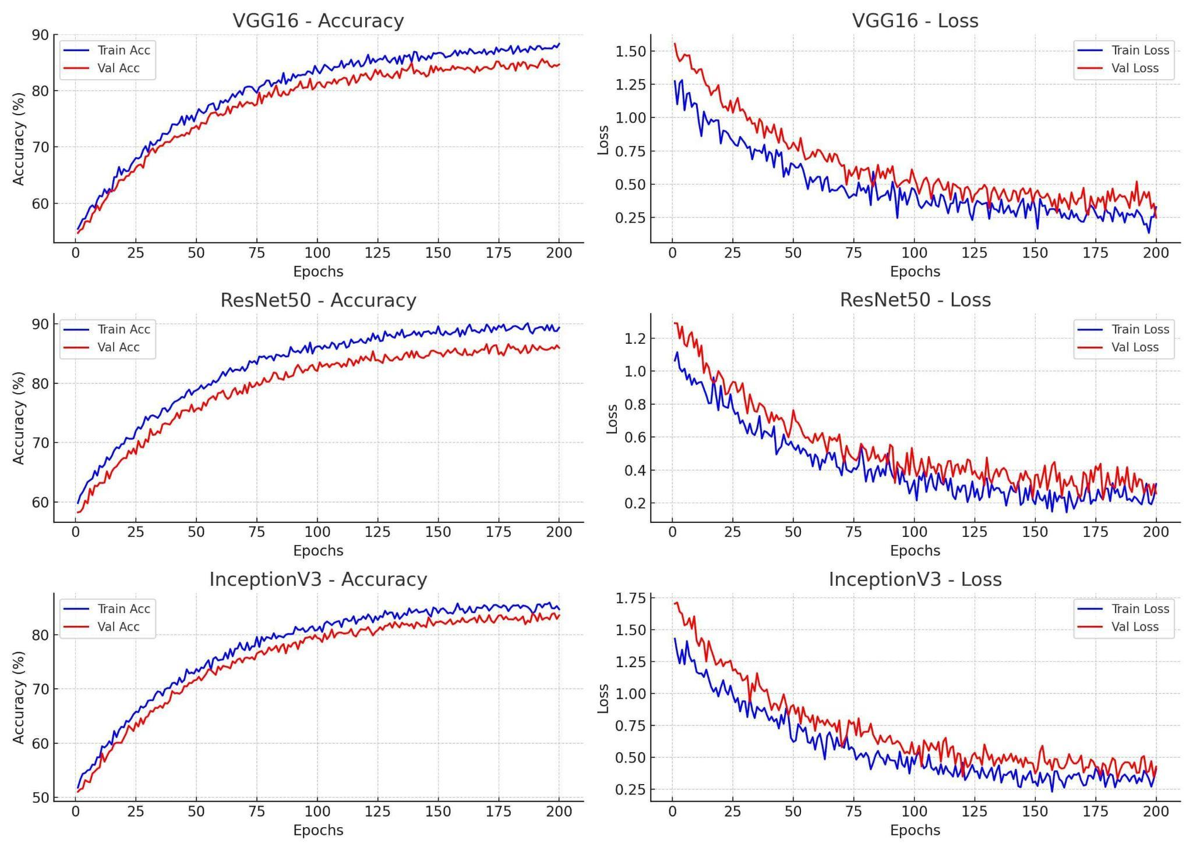
Figure 3: Training behavior of different CNN models.

Table 4: Summary of Evaluated Model Architectures for Race Classification

Model Architecture | Key Description
CNN (Baseline) | 3 conv layers (ReLU, max pooling); FC: 128 → 64 units; Dropout 0.3; Softmax output
VGG16 [12] (Transfer Learning) | Pretrained VGG16 backbone; Global avg pooling; Dense 256 (ReLU); Dropout 0.3; Softmax; last 4 conv layers fine-tuned
ResNet50 (Transfer Learning) | Pretrained ResNet50 backbone; Global avg pooling; Dense 256 (ReLU); Dropout 0.3; Softmax; last 4 conv layers fine-tuned
Inception (Transfer Learning) | Pretrained Inception-v3 backbone; Global avg pooling; Dense 256 (ReLU); Dropout 0.3; Softmax; last inception blocks fine-tuned
MTCNN + FaceNet + MLP | MTCNN for detection/alignment; FaceNet (128-D embeddings); Logistic Regression classifier
MTCNN + FaceNet + MLP (Proposed) | MTCNN for face detection and alignment; parallel feature extraction using FaceNet and ResNet50; fused features classified using an MLP (Dense 256, Dense 128, ReLU, Dropout 0.3, Softmax).
The fusion approach consistently outperformed single-feature baselines. Table 5 shows accuracy, precision, recall, and F1-score. We have trained all the models on the same dataset. Figure 4 visualizes the improvement. On the curated dataset, the fusion model reached 95.2% accuracy, compared to 90.1% for ResNet50 alone and 93.0% for FaceNet + MLP.
Table 5: Performance of Baseline, Benchmark, and Proposed Model Evaluated on the Custom Dataset
Model / Method | Accuracy (%) | Precision | Recall | F1-score
CNN | 84.0 | 0.84 | 0.83 | 0.836
VGG16[12]  (fine-tuned) | 89.3 | 0.89 | 0.90 | 0.895
ResNet50 [13]  (fine-tuned) | 90.1 | 0.90 | 0.91 | 0.905
InceptionV3[29] (fine-tuned) | 88.5 | 0.88 | 0.89 | 0.883
FaceNet embeddings + Logistic Regression [30] | 91.0 | 0.91 | 0.91 | 0.910
FaceNet + MLP [31] | 93.0 | 0.92 | 0.91 | 0.925
Proposed Fusion (ResNet50 + FaceNet + MLP) | 95.2 | 0.939 | 0.95 | 0.948
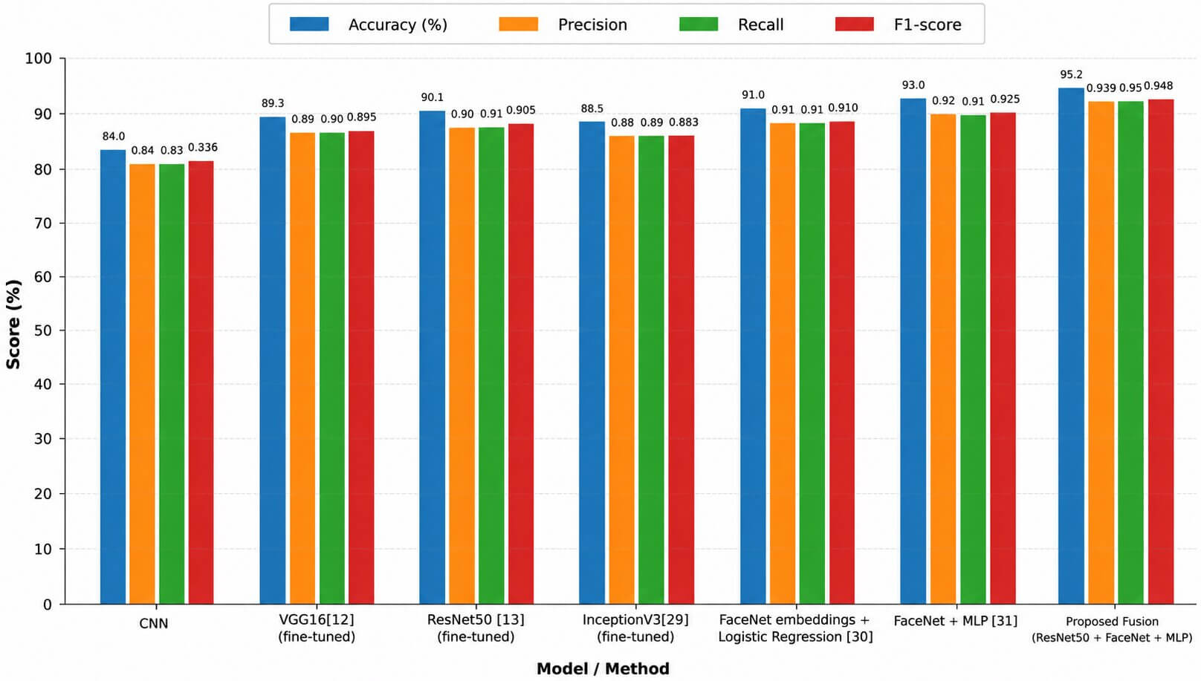
Figure 4: Visual comparison of accuracy, precision, recall, and F1-score across models. The fusion approach consistently outperforms single-feature baselines
Fairness Evaluation
To examine the fairness of the proposed model, the classification performance was analyzed separately for Group A and Group B using the confusion matrix. The model correctly classified 40 samples from Group A and 41 samples from Group B, while only two samples from each group were incorrectly classified. This similar error distribution shows that the model performs consistently across both groups without a noticeable preference toward one group over the other.
The comparable classification results for both groups indicate that the proposed ResNet50–FaceNet fusion approach provides balanced predictive performance. These findings suggest that the model is able to learn discriminative facial features while maintaining a similar level of reliability across the evaluated demographic groups.
Cross-Dataset Evaluation
To evaluate the generalization ability of the proposed model, we tested it on the UTKFace [27] and FairFace [28] datasets without any additional training or fine-tuning. A total of 100 (50 Group A + 50 Group B) facial images from each dataset were used for evaluation. To maintain consistency, the original race annotations were grouped into two demographic categories: Group A (Asian) and Group B (Non-Asian), as presented in Table 6. The proposed feature fusion model achieved 88.7% accuracy on UTKFace and 87.9% on FairFace, outperforming ResNet50 (74.8% and 76.1%) and FaceNet + MLP (85.4% and 84.6%), indicating good generalization across different datasets.
Table 6. Demographic group mapping used for cross-dataset evaluation on UTKFace and FairFace
.
Dataset | Original Race Groups | Mapped Demographic Groups
UTKFace dataset [27] | White, Black, Asian, Indian, Others | Group A: Asian  Group B: White, Black, Indian, Others
FairFace[28] | White, Black, East Asian, Southeast Asian, Indian, Middle Eastern, Latino_Hispanic | Group A: East Asian, Southeast Asian  Group B: White, Black, Indian, Middle Eastern, Latino_Hispanic

Table 7. Complexity analysis of evaluated models.

Model | Total/Frozen Parameters (M) | Trainable Parameters (M) | Inference (ms/img)
ResNet50 (fine-tuned) | 25.6 | 2.5 | 18
FaceNet + MLP | 24 | 1.5 | 22
Proposed Fusion | 48 | 3.5 | 27.3
The fusion model has slightly higher parameters and inference time due to dual-stream computation, but remains efficient with an average inference time under 30 ms per image on GPU. Table 7. demonstrates a practical balance of the proposed model between accuracy and computational cost.
Discussion
The results show that the proposed hybrid fusion framework consistently outperforms single-feature approaches. By combining CNN-derived features with FaceNet embeddings, the model leverages complementary strengths: CNNs capture dataset-specific visual cues, while embeddings preserve identity-related information. This fusion allows the model to effectively capture subtle inter-group differences while remaining robust to variations in pose, illumination, and expression.
The improvements observed in cross-dataset evaluations on UTKFace and FairFace suggest that the fused representation generalizes better than standalone features. This indicates that integrating task-specific and identity-preserving features can mitigate overfitting to dataset-specific patterns, a common challenge in demographic group classification.
However, several limitations should be considered when interpreting the findings of this study. Although the curated dataset includes a variety of facial images, it is relatively small and may not fully represent the diversity of facial appearances across different populations. Moreover, the model was evaluated on a limited test set, which may influence the consistency of the reported performance. As a result, the reported accuracy should be viewed in the context of the current experimental setup rather than as a definitive measure of real-world performance. In addition, grouping faces into broad demographic categories inevitably simplifies the rich diversity that exists within human populations. The proposed fusion model also incurs a slightly higher computational cost than single-stream approaches, which could limit its use in applications with strict real-time or hardware constraints.
Future work will focus on validating the proposed approach on larger and more diverse datasets using more comprehensive evaluation strategies, such as k-fold cross-validation and independent test sets. Further improvements may also be achieved by incorporating fairness-aware learning techniques and exploring advanced architectures, including Vision Transformers and multimodal fusion methods, to enhance both model performance and robustness.

Conclusion
This study introduced a hybrid deep feature fusion framework for robust demographic group classification in facial images. By integrating CNN-derived features with identity-preserving FaceNet embeddings, the proposed approach consistently outperformed standalone methods, achieving high accuracy and strong generalization across both curated and benchmark datasets.
The findings highlight the value of combining complementary feature representations to capture subtle inter-group differences while maintaining robustness to pose, illumination, and expression variations. Although the study used relatively small datasets and broad demographic categories, the results demonstrate that hybrid feature fusion is a promising strategy for accurate, generalizable, and fairness-conscious facial analysis.
Future work should focus on larger and more diverse datasets, fairness-aware model design, and advanced architectures to further enhance robustness and ethical reliability in demographic group classification tasks.

Declarations
Availability of data and material
The UTKFace [27] and FairFace [28] datasets used in this study are publicly available. The code and sample images supporting this study are publicly available at https://github.com/ali171m/Face-Classification.
Competing interests
The authors declare that they have no competing interests.
Funding
This research received no specific grant from any funding agency in the public, commercial, or not-for-profit sectors.
Authors' contributions
All authors contributed to the writing, reviewed the manuscript and approved the final version.

References
[1] A. K. Jain, A. Ross, and K. Nandakumar, 50 Years of Biometric Research. Cham, Switzerland: Springer, 2016.
[2] J. Hong, B. Suh, and S. Kim, "Culturally adaptive user interfaces," in Proc. SIGCHI Conf. Human Factors Comput. Syst. (CHI), New York, NY, USA, 2014, pp. 3543–3552.
[3] S. Kamran, M. Adeel, et al., "Demographic profiling from social media images," Multimedia Tools and Applications, vol. 78, no. 8, pp. 10783–10804, 2019.
[4] J. Buolamwini and T. Gebru, "Gender Shades: Intersectional Accuracy Disparities in Commercial Gender Classification," in Proc. 1st Conf. Fairness, Accountability and Transparency (FAT), 2018, pp. 77–91. 10.48550/arXiv.1802.06820
[5] M. Wang and W. Deng, "Addressing bias in facial recognition algorithms," IEEE Transactions on Pattern Analysis and Machine Intelligence, vol. 41, no. 3, pp. 435–447, 2019.
[6] C. Shan, "Illumination normalization for robust face recognition: A survey," in Proc. ACM Int. Conf. Multimedia, 2011, pp. 49–56.
[7] Z. Lu, C. Ding, and D. Tao, "Cross-domain race classification from facial images," in Proc. IEEE Conf. Comput. Vis. Pattern Recognit. (CVPR), 2020, pp. 6781–6790.
[8] T. Ojala, M. Pietikäinen, and T. Mäenpää, "Multiresolution gray-scale and rotation invariant texture classification with local binary patterns," IEEE Transactions on Pattern Analysis and Machine Intelligence, vol. 24, no. 7, pp. 971–987, Jul. 2002. 10.1109/TPAMI.2002.1017623
[9] N. Dalal and B. Triggs, "Histograms of oriented gradients for human detection," in Proc. IEEE Comput. Soc. Conf. Comput. Vis. Pattern Recognit. (CVPR), vol. 1, San Diego, CA, USA, 2005, pp. 886–893.10.1109/CVPR.2005.177
[10] C. Cortes and V. Vapnik, "Support-vector networks," Machine Learning, vol. 20, no. 3, pp. 273–297, 1995. 10.1007/BF00994018
[11] J. Deng, W. Dong, R. Socher, L.-J. Li, K. Li, and L. Fei-Fei, "ImageNet: A large-scale hierarchical image database," in Proc. IEEE Conf. Comput. Vis. Pattern Recognit. (CVPR), Miami, FL, USA, 2009, pp. 248–255. 10.1109/CVPR.2009.5206848
[12] K. Simonyan and A. Zisserman, "Very deep convolutional networks for large-scale image recognition," in Proc. Int. Conf. Learn. Represent. (ICLR), 2015.
[13] K. He, X. Zhang, S. Ren, and J. Sun, "Deep residual learning for image recognition," in Proc. IEEE Conf. Comput. Vis. Pattern Recognit. (CVPR), Las Vegas, NV, USA, 2016, pp. 770–778. 10.1109/CVPR.2016.90
[14] F. Schroff, D. Kalenichenko, and J. Philbin, "FaceNet: A unified embedding for face recognition and clustering," in Proc. IEEE Conf. Comput. Vis. Pattern Recognit. (CVPR), Boston, MA, USA, 2015, pp. 815–823.10.1109/CVPR.2015.7298682
[15] J. Deng, J. Guo, N. Xue, and S. Zafeiriou, "ArcFace: Additive angular margin loss for deep face recognition," in Proc. IEEE Conf. Comput. Vis. Pattern Recognit. (CVPR), Long Beach, CA, USA, 2019, pp. 4685–4694. 10.1109/CVPR.2019.00482
[16] M. Izadi, A. Saberi, and H. Aghaeinia, "Feature fusion for gender classification in the wild," Multimedia Tools and Applications, vol. 78, no. 3, pp. 3649–3670, 2019.
[17] K. Zhang, Z. Zhang, Z. Li, and Y. Qiao, "Joint face detection and alignment using multitask cascaded convolutional networks," IEEE Signal Processing Letters, vol. 23, no. 10, pp. 1499–1503, Oct. 2016. 10.1109/LSP.2016.2603342
[18] N. Srivastava, G. Hinton, A. Krizhevsky, I. Sutskever, and R. Salakhutdinov, "Dropout: A simple way to prevent neural networks from overfitting," Journal of Machine Learning Research, vol. 15, no. 56, pp. 1929–1958, 2014.
[19] W. Liu, Y. Wen, Z. Yu, M. Li, B. Raj, and L. Song, "SphereFace: Deep hypersphere embedding for face recognition," in Proc. IEEE Conf. Comput. Vis. Pattern Recognit. (CVPR), Honolulu, HI, USA, 2017, pp. 6738–6746. 10.1109/CVPR.2017.713
[20] J. P. Robinson, G. Livitz, Y. Henon, C. Qin, Y. Fu, and S. Timoner, "Face recognition: Too bias, or not too bias?" in Proc. IEEE/CVF Conf. Comput. Vis. Pattern Recognit. Workshops (CVPRW), Seattle, WA, USA, 2020, pp. 1–10. 10.1109/CVPRW50498.2020.00009
[21] J. Deng, J. Guo, Y. Zhou, J. Yu, I. Kotsia, and S. Zafeiriou, "RetinaFace: Single-Shot Multi-Level Face Localisation in the Wild," in Proc. IEEE/CVF Conf. Comput. Vis. Pattern Recognit. (CVPR), Seattle, WA, USA, 2020, pp. 5203–5212. 10.1109/CVPR42600.2020.00525
[22] S. Zafeiriou, C. Zhang, and Z. Zhang, "A survey on face detection in the wild: Past, present and future," Computer Vision and Image Understanding, vol. 138, pp. 1–24, Sep. 2015. 10.1016/j.cviu.2015.03.015
[23] S. Izadi, A. Abdollahi, and H. Demirel, "Feature-level fusion from facial attributes for face recognition," arXiv preprint, arXiv:1909.13126, 2019.
[24] R. Ranjan, S. Sankaranarayanan, A. Bansal, N. Bodla, J.-C. Chen, V. M. Patel, C. D. Castillo, and R. Chellappa, "Deep learning for understanding faces: Machines may be just as good, or better, than humans," IEEE Signal Processing Magazine, vol. 35, no. 1, pp. 66–83, Jan. 2018. 10.1109/MSP.2017.2764116
[25] C. Szegedy, V. Vanhoucke, S. Ioffe, J. Shlens, and Z. Wojna, "Rethinking the inception architecture for computer vision," in Proc. IEEE Conf. Comput. Vis. Pattern Recognit. (CVPR), Las Vegas, NV, USA, 2016, pp. 2818–2826. 10.1109/CVPR.2016.308
[26] T. I. Baig, T. M. Alam, T. Anjum, S. Naseer, A. Wahab, M. Imtiaz, and M. M. Raza, "Classification of human face: Asian and non-Asian people," in Proc. Int. Conf. Innovative Computing (ICIC), Lahore, Pakistan, 2019, pp. 1–6. 10.1109/ICIC48496.2019.896672
[27] Z. Zhang, Y. Song, and H. Qi, "Age progression/regression by conditional adversarial autoencoder," in Proc. IEEE Conf. Comput. Vis. Pattern Recognit. (CVPR), Honolulu, HI, USA, 2017, pp. 5810–5818. 10.1109/CVPR.2017.615
[28] K. Kärkkäinen and J. Joo, "FairFace: Face attribute dataset for balanced race, gender, and age for bias measurement and mitigation," in Proc. IEEE/CVF Winter Conf. Appl. Comput. Vis. (WACV), Waikoloa, HI, USA, 2021, pp. 1548–1558. 10.1109/WACV48630.2021.00159
[29] V. Mikaeel, B. Turan, and M. Abdulrazaq, "Facial race and gender recognition based on convolutional neural network models," Gaziosmanpaşa Bilimsel Araştırma Dergisi (GBAD), vol. 13, no. 3, pp. 1–18, Dec. 2024.
[30] A. Swaminathan, M. Chaba, D. K. Sharma, and Y. Chaba, "Gender classification using facial embeddings: A novel approach," Procedia Computer Science, vol. 167, pp. 2634–2642, 2020. 10.1016/j.procs.2020.03.320
[31] A. Das, A. Dantcheva, and F. Bremond, "Mitigating bias in gender, age and ethnicity classification: A multi-task convolution neural network approach," in Proc. Eur. Conf. Comput. Vis. (ECCV) Workshops, Munich, Germany, 2018.

