Resilience and Cybersecurity Enhancement of Smart Grids Using Machine Learning
Fahad Ali^{*1}, Taila Jabeen¹, Hafiz Muhammad Ashja Khan¹
¹ University of Management and Technology, Lahore, Pakistan
Correspondence:
Fahad Ali : fahad.ali@umt.edu.pk
Article Link: https://www.brainetwork.org/index.php/jcai/article/view/196
DOI: https://doi.org/10.69591/jcai.3.2.4
  Volume 3, Issue 2, 2025  Funding  No  Copyright  The Authors  Licensing  licensed under a Creative Commons Attribution 4.0 International License. | Citation: Ali, F., Jabeen, T., & Khan, A. (2026). Resilience and cybersecurity enhancement of smart grids using machine learning. Journal of Computing and Artificial Intelligence, 3(2).  Conflict of Interest: Authors declared no Conflict of Interest  Acknowledgment: No administrative and technical support was taken for this research  Article History Submitted: Sep 02, 2025  Last Revised: Nov 16, 2025  Accepted: Dec 13, 2025    An official Publication of  Beyond Research Advancement & Innovation Network, Islamabad,  Pakistan

Resilience and Cybersecurity Enhancement of Smart Grids Using Machine Learning
Fahad Ali *, Taila Jabeen, Hafiz Muhammad Ashja Khan
University of Management and Technology, Lahore, Pakistan

Abstract
The development of modern power infrastructure witnessed a paradigm shift due to the appearance of smart grid (SG) technology. Smart grids integrate various distributed energy resources (DERs), advanced metering, and two-way communication capabilities. The integration results in significant advancements in terms of control and efficiency, but at the same time, new vulnerabilities are introduced into the system. Natural disasters such as floods, earthquakes, and wildfires, as well as cyberattacks on the SG system, proved that cascading failures may occur within the smart grid architecture while being unattainable in a traditional power grid. In light of these challenges, resilience transitioned from a qualitative characteristic to an important design parameter. This article reviews the threat landscape facing today's SGs and discusses the methodologies and metrics used in measuring and achieving resilience. An emphasis is placed on machine learning (ML) algorithms, especially recurrent neural networks, which became widely popular in detecting anomalies and attacks based on state data analysis. The study concludes with an evaluation of existing techniques' shortcomings and potential areas of future research.
Keywords: Smart Grid, Smart Grid Security, Intrusion Detection System, Machine Learning, Resilience, Cybersecurity, False Data Injection Attack, Disasters, Distributer Energy Resources.

Introduction
Whereas earlier power grids used to work in a one-way direction and were independent of any external network, Smart Grids facilitate two-way exchange of both electricity and data. Communication is now done between control systems and external networks to ensure efficient load balancing, remote detection of faults, and the use of distributed energy such as solar power. Connectivity brings with itself new challenges of cybersecurity, which have no equivalents in the case of normal infrastructure. In terms of operation, the Smart Grid can be considered a cooperative environment involving generation plants, customers, and distributed energy sources using sensors, microprocessors, and communication systems for automatic monitoring and self-adjustment. A hierarchical communication model involving smart meters, aggregators, and central stations makes decision-making effective and maintains system stability. You can see what the whole system looks like in Figure 1.

Figure 1. Smart grid architecture integrating power distribution, communication systems, and advanced control technology
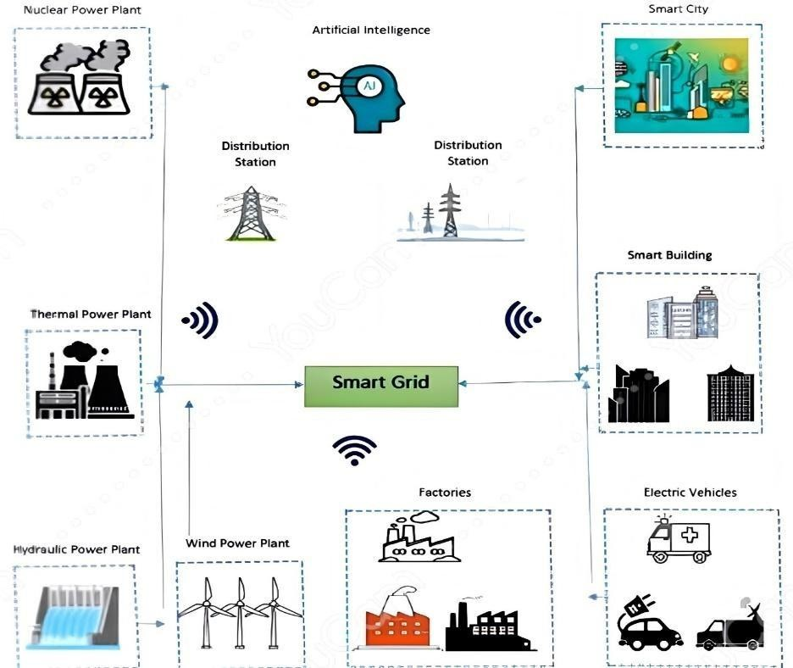

Security of Smart Grid
In expanding the infrastructure of Smart Grid (Smart Grid), there is an installation of a lot of remote terminal units (RTUs), intelligent meters, Distributed Energy Resources (DERs), and physical sensors which operate through the telecommunication network, involving several layers of communications [6]. As a result, the grid operates in a synchronized and data-intensive fashion. At the same time, however, being dependent on data exchange, vulnerabilities in the communications layer could translate into vulnerabilities in the physical layer as well. This is why communication security becomes not only an IT problem but also an operational reliability concern. [7].
Concept of Resilience
Resilience stems from the Latin verb resilio, meaning to rebound, bounce back, spring back up. As applied to electric power systems, resilience acquires its particular definition as the ability of an electric power system to minimize the magnitude and duration of the impact of a disruptive event and then restore to its normal operation state. According to the National Infrastructure Advisory Council (NIAC), resilience includes the capability of absorbing and adapting to shocks, thriving under pressure and rapid recovery. As such, a resilient smart grid system is one that does not simply endure a disruption but also recovers quickly enough so that recovering actually matters.
Cybersecurity Threats
The area that SGs know more about, in terms of attack types, is false data injection (FDI) attacks, and rightly so. An attacker, able to poison data at a state estimator, can trick the control system into actions that are rational given the fake data, but dangerous in the real world (unwanted load shedding, equipment over/under-stressed or blackouts that appear to be faults and not attacks [8]). However, differentiating an attack from a physical anomaly (branch on a power line, faulty meter) is among the more difficult detection challenges. Complete taxonomies of the attack landscape-from applicable standards for communications to governing regulations-can be found in recent survey papers [9].
Role of Machine Learning
Rule-based detection systems perform quite well if the attacker behavior profile is known beforehand, but it's the adaptivity and obsolescence of rule sets in the face of the adversary's counter-actions that proves to be the challenge. ML systems actually "learn" what constitutes normal traffic from data, allowing them to flag behaviors for which no rules existed [10]. The primary paradigms are supervised learning (based on labelled training data), unsupervised learning (based on discovery of pattern in data, no labels needed), and reinforcement learning (policy based on interaction and reward/punishment in the environment). These can naturally be mapped to different stages of detection and response.
The remainder of this paper proceeds as follows. Section II reviews prior work on SG resilience and ML-based security. Section III presents the methodology, covering resilience attributes, natural and cyber threat analysis, quantitative assessment, and restoration strategies. Section IV offers conclusions and research directions.

Literature Review
The past decade has seen both the frequency and sophistication of attacks on SG infrastructure rise, engineering the necessity of resilience as a primary design consideration, not an afterthought. A diverse array of techniques to describe, measure and improve SG resilience have been developed within the research community, from qualitative frameworks to quantitative metrics, which combined help paint a more comprehensive picture of system robustness and recovery performance [11].
One stream of research addresses the control-theoretic aspect of stability. Coupling conventional control, control theory for communication delays, and DESSs, researchers have presented delay-adaptive techniques that manage communication delays, optimize power flows while relying on simplied system models [12]. Due to the incorporation of renewable energy sources and digital technologies into the grid, stability issue in the past has taken a cyber aspect along with the physical aspect. Specifically, a customized nonlinear distributed controller is proposed to stabilize synchronous generators under cyber-physical disturbances and communication delays [13]. In other aspect, detailed characterizations of various natural disasters have been conducted and have subsequently provided inputs to the construction of adaptive planning frameworks applicable in many environmental hazard situations [14]. There are also contributions in the domain of AI: machine learning is shown to achieve cognitive, computational, and perceptual capabilities necessary to enhance grid's awareness and to speed up and improve accuracy in recovery strategies [15][116]. Federated learning with LSTM and CNN models, applied to the SCADA/ICS context, have also been studied and proved effective at detecting attacks like data spoofing, command injection and DDoS with minimal latency while satisfying the constraints of security policies [116]. Models based on these principles are able to limit unserved load during high-impact low-probability (HILP) events and researchers typically analyze resilience in three periods: planning, real-time response and recovery [16]. Practical concerns and challenges are still acknowledged but the benefits of multiple control layers arranged in a distributed architecture on stability enhancement are reported to be substantial [17]. With respect to measurement of resilience, a multitude of resilience metrics exist, none of which has earned universal acceptance [18]; mapping of strength and weakness of each metric has also been explored without achieving a consensus. Another concern addresses control level cyber-attacks; distributed generators are configured to independently serve critical load as contingency under attacks and framework designed for this to be secure are also being studied [19]. A case study focused on the resilience of a grid in Shandong Province under a scenario of partial or total failure confirmed that prioritizing certain components in reconstruction improves resilience outcome in a multiple repair strategies scenario [20].
On the detection side, FDI detection is being conducted by CNN and LSTM models for SGs enriched in renewable energy resources, and high accuracy (above 98% with specialized pre-processing) have been obtained using synthesized attack data [21]. Furthermore, an integrated flexible-response framework that combines preventive and emergency components and modeled as a two-phase mixed integer optimization through nested column generation, was also proposed [21]; followed by sensitivity and predictive inference analysis, in which the influences of major variables are quantified [22]. KNN, SVM and RF classifiers were applied for intrusion detection in SG communication networks and attention was also given to legal and regulatory issues [23]. Table 1 provides a summary on those research works and similar ones.

Table 1. Systematic literature review: smart grid resilience approaches and evaluation methods.

YEAR | REF. | THEME OF RESEARCH | METHOD / APPROACH | VENUE
2025 | [114] | Electrical resilience measurement | ML classifiers for cyberattack detection | Journal of Communication
2020 | [10] | SG resilience measurement | Qualitative and quantitative metric comparison | Elsevier
2019 | [11] | SG stability and resilience | Delay-adaptive control | Elsevier
2016 | [12] | Transient stability in SG | Distributed non-linear controller | IEEE
2018 | [13] | Electric system resiliency | Resilience strategies and measures | Global Energy Interconnection
2020 | [14] | Power system resilience | ML/AI techniques | IEEE
2019 | [15] | Electric system resilience | Planning, response and restoration | IEEE
2018 | [16] | SG resilience | Storage Multi-Agent framework | IEEE
2021 | [17] | Grid resilience evaluation | Resilience metric assessment | Int. Trans. Electr. Energ. Syst.
2021 | [18] | Cyber-resilient grid control | Cyber-attack resilient control framework | IEEE
2021 | [19] | Power grid resilience | Component recovery strategies | –
2017 | [20] | SG integrated resilience | Preventive/emergency response framework | IEEE
2020 | [21] | SG resilience modeling | Bayesian Network approach | J. Comp. Design Eng.

For addressing the confidentiality issues, the SG security practice now typically opts to use combinations of encryption, VPN tunneling (to make packet sniffing unfeasible), and network coding [24]. On the data integrity front, we see the use of cryptographic techniques, trusted-network schemes, power fingerprinting, and volt-var control; authentication techniques further serve the purpose by both confirming identity of the devices, and validating data values.
At the operational layer, the analysis of IEC 61850 GOOSE messages is found to be effective in intrusions detection, and several algorithms are benchmarked on their prediction accuracy [25]. ML traffic monitors have high accuracy in classifying normal as malicious traffic [26]. A self-adaptive scheme with semi-supervised domain adversarial training is developed, validated on ISO New England grid data, and tested against varied attack types, shows robust performance [27]. In a 2025 publication, using explainable ML with ensemble classifiers and multi-strategy feature selection, detection of physical disturbances and cyber-attacks simultaneously from PMU data sets is demonstrated and interpreted [118]. An important lesson from [28] is that, to date, no technique makes an SG impervious to FDIAs, effectiveness depends on an architecture and operational, as well as the threat signature. Layering defenses and continuously updating them, including newer tools such as diffusion models and advanced observer designs, is the only realistic strategy as demonstrates in the figure 2 the ARIES model architecture.
Further work builds on this trend. The HST-GAT method was introduced for FDIA, in which graph attention is used first to learn the spatial dependencies resulting from the grid's topological structure, while time is then accounted for by modeling the sequential behavior of measurements, thus making such networks more interpretable than prior deep-learning frameworks [121]. For electricity theft detection, blockchain-based logging combined with LSTM autoencoder is used to ensure integrity of the results obtained from detection, linking detection accuracy with data integrity [122]. On the planning side, a review article examines the applicability of deep reinforcement learning in designing robust power systems, mapping the model-free and data-driven decision-making approach onto different stages of planning and outlining policy transfer as the key challenge [123]. A hybrid ensemble of three decision trees improved on standalone algorithm accuracy by 3.63% in IoT-integrated SG intrusion detection [29].

Figure 2. ARIES Model Architecture Featuring a Three-Layer Intrusion Detection
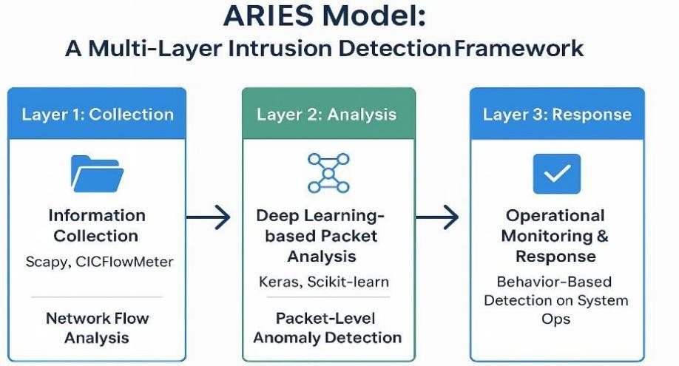
Framework [39].

Feature-based IDS evaluated on the KDD99 and NSL-KDD datasets achieved false alarm rates of 0.5% and 0.08% respectively, with accuracy above 99% [30]. Recursive Feature Elimination and Boruta selection have been used to keep only informative features. On CIC-IDS2018, RF and XGBoost reached recall rates of 99.75% and 99.87% [31]. Physical layer security methods for detecting and localising both active attackers and eavesdroppers have achieved near-ideal detection rates in simulation [32].
Benchmarking individual classifiers, CART achieved 99.92% accuracy, followed by K-NN, C4.5, and ANN at 99.9%. REP Tree and RF reached 99.88%, SVM recorded 98.3%, and a REP Tree bagging ensemble reached 99.94% [33]. Fog-computing-based hierarchical distributed IDS systems model smart-meter state transitions via Markov chains and have outperformed flat-topology alternatives [34].
A WOA-trained ANN has been tested on binary, triple, and multiple cyber-attack classification, outperforming standard classifiers in structured evaluation phases [35][36]. OS-ELM applied to AMI security, with gain-ratio dimensionality reduction, outperformed batch-mode methods on both speed and accuracy [37]. A multi-SVM IDS for neighborhood area networks (NANs) using mutual-information feature selection outperformed ANN-based alternatives on detection ratio, making it well-suited to AMI protection [38].
The ARIES system deploys a multi-layer ML architecture trained on power-plant operational data; its third tier, ARIES-GAN, achieved the highest detection accuracy of any configuration tested [39].
For FDI detection, three topological approaches have been compared: linear regression (FDILR), time-stamped linear regression (FDILRT), and delta thresholds (FDIDT). FDILRT outperformed FDILR; FDIDT made attacks effectively invisible [40]. An approach that identifies concept drifts—shifts in data distribution—and folds them into training data has achieved high detection accuracy while reinforcing existing countermeasures [41].
Hierarchical ensemble methods outperformed individual models, catching up to 73% of attacks even without supervision; feature reduction substantially accelerated training [42].
FDI detection via ML falls into three sub-problems: NTL detection, state estimation (SE), and load forecasting. For NTL CNNs and encryption based methods have been evaluated [43][44]. For SE standard classification techniques like SVM, KNN and ANN [45] have been considered with Isolation Forest for ensemble improvement [46]. Figure 3 demonstrates the conceptual FDI detection framework. Among all ML approaches, RNNs have shown the strongest fit for detecting temporal anomalies in sequential grid data [47].
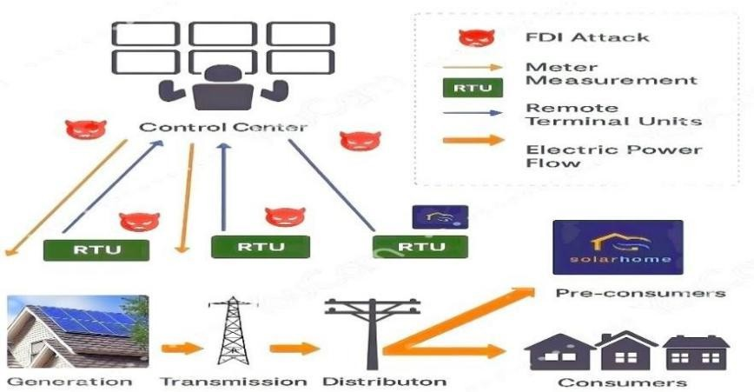
Figure 3. Conceptual Framework Illustrating False Data Injection Attack Detection Using Machine Learning Techniques

An ELM-based OCON framework separates authentic from falsified measurements precisely. Simulations confirm it can locate compromised buses and recover corrupted data, including attacks designed to be unobservable by conventional means [48][49]. Multi-label classification has further improved detection robustness [50]. Separately, a federated deep learning approach integrating Transformer self-attention with the Paillier cryptosystem achieved privacy-preserving FDIA detection in distributed edge environments, validated on both IEEE 14-bus and 118-bus systems [115].
For energy theft, RF, gradient boosting (GB), and decision trees (DT) have all been evaluated; in combination with clustering, GB and RF both outperformed DT with accuracy rates of 88.6%, 88.1%, and 87.0% respectively [51]. Under ToU pricing, GB-based window detectors reached AUC 0.90 via Extra Trees and RF, with bagging showing the strongest precision [52]. RUSBoost and LSTM-based approaches both performed well on ROC, precision, F1, and recall metrics [53].
ML has also been applied to the problem of separating natural disturbances from cyber-caused anomalies. RF achieved the highest detection capability across classifiers tested [54]. A CART-based anomaly IDS for AMI reached 0.996 accuracy and 0.993 true positive rate [55]. Symbolic dynamic filtering (SDF) for feature extraction achieved 99% detection accuracy in anomaly identification.
For DoS detection, DT, SVM, and Naïve Bayes were benchmarked on KDD99, with SVM winning [56]. A DDoS model based on multilevel autoencoders combined with MKL achieved high detection accuracy [57]. A two-layer hierarchical ML model reached 95.44% accuracy for SG cyber-attack detection [58]. Table 2 records notable historical cyber incidents.
Table 2. Major cyberattacks: affected entities, techniques, and timelines.
ATTACK SUMMARY | AFFECTED ENTITIES | TECHNIQUE | YEAR | MONTH
200M usernames/passwords leaked | – | – | 2012 | –
3B user accounts compromised | – | – | 2013 | –
500M user accounts compromised | – | – | 2014 | –
500M customer privacy breached | – | – | 2018 | Sep
4M accounts hacked | – | Local File Inclusion (LFI) | 2015 | –
143M records + 200K credit cards (Canada, UK, USA) | – | Apache Struts vuln. | 2017 | Jul
123M household records leaked | – | – | 2017 | Mar
40M banking + 70M personal records | – | RAM Scraping | 2013 | Dec
100M credit cards + 20M user data | – | Insider Attack | 2014 | Jan
77M user records hacked | – | SQL Injection | 2011 | Apr

Methodology
Overview of Resilience
There is not one single aspect of power system resilience, but several. No index has fully captured power system resilience, and the attributes that constitute power system resilience will vary greatly depending on whether the disturbance at hand is a slow flood or an immediate cyber intrusion. Among these, four aspects stand out as recurring.
1) Reliability and robustness
Reliability deals with high-frequency low-impact disturbances-equipment degradation, simple fault, problems the grid deals with day in and day out. Resilience mostly relates to the "tail"-low-probability but high-impact events, such as severe weather
storms or coordinated attacks [59]. Robustness describes the ability of the power system to sustain itself with acceptable performance degradation from the impact of an unexpected disruption [16].
2) Flexibility
Flexibility describes the ability of the system to establish a new stable state after the disturbance even if it is significantly different from the original state. Resilience asks if the system can restore itself to the original stable state. In the context of SGs, both concepts can be tied to self-healing and adaptive reconfiguration [11].
3) Vulnerability
Vulnerability is a system's propensity for harm. In the context of SGs, it exists in three areas-physical, cyber, and cyber-physical (i.e., the cyber means are used to cause physical disruption) [60]. Understanding all three vulnerability areas is fundamental to assessing the risks involved.
4) Maintainability
Maintainability refers mainly to the speed of recovery after a disturbance. A quicker recovery implies better maintainability, and thus increases reliability and robustness [16]. Healing time for individual components establishes a minimum value for recovery time. Figure 4 depicts the interrelationship among all four features.
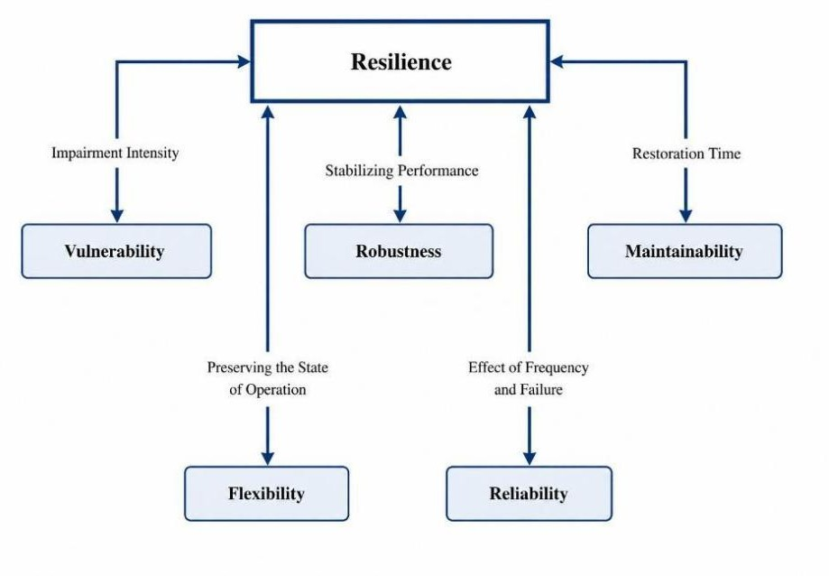
Figure 4. Key Attributes of Resilience in Smart Grid Systems

Overview of Security Issues in Smart Grids
SGs are exposed to threats that go well beyond what traditional grid operators had to worry about. Both grid stability and consumer privacy can be compromised if energy flows are interrupted or if metering data is intercepted. A practical example: an adversary who modifies current sensor readings upstream of the state estimator can push the control system into taking actions that look correct on paper but cause real harm misrouting power, concealing theft, or precipitating outages.
Getting comprehensive protection right is hard. Attack surfaces are large and heterogeneous, and attackers tend to be patient and systematic. Figure 5 shows a mythological framework for analyzing the security and the countermeasures and we get a typical intrusion proceeds through four stages:
Reconnaissance: gathering information about target systems, mapping topology, and identifying communication endpoints.
Scanning: actively probing ports and services to locate exploitable weaknesses.
Exploitation: using the weaknesses found to gain unauthorized access and control.
Persistence: once inside, establishing mechanisms that maintain access across reboots, patch cycles, and other countermeasures.
Figure 5. Methodological Framework for Analyzing Security Threats and Countermeasures in Smart Grids.
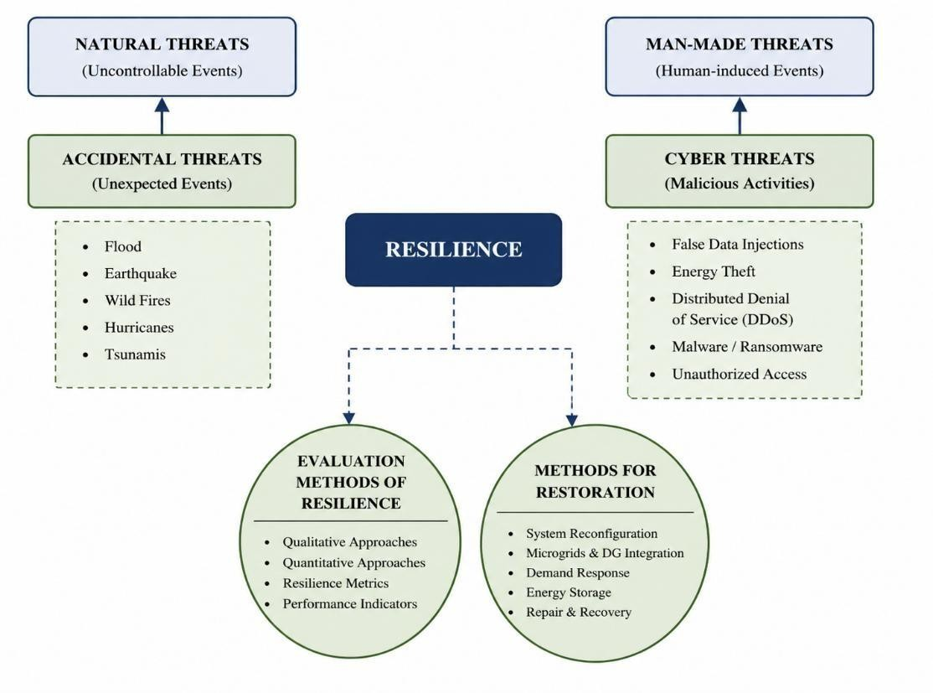
Accidental Threats
Physical destruction of infrastructure due to natural phenomenon is the second great problem. Each of the threat described in this section- flood, hurricane, wild-fire and earthquake-has different timescale of notification, spatial extent, damage mechanism and thus, the strategy to deal with it has to be specific.
1) Floods
Flood is one of the most costly and common natural disaster associated with damages of infrastructure. In the context of power grid, researchers have shown a significant increased tendency toward not only recovery but also, grid designing to resist the flood [61]. Automation of flood extent mapping from TerraSAR-X satellite imagery has been developed using Taguchi optimization of spectral indices [61], and InSAR technology has been shown to be a very promising method to map the inundation in urban and agriculture areas [62].
The resilient trapezoid method for characterizing power grid during catastrophic events [63], anticipatory microgrid dispatching during flood event, providing critical loads with electricity [64] and a HAZUS approach to estimating flooding damage to infrastructure are the various methods employed [65]. Other related methods included; historical data analysis, rainfall-based prediction method [66], distribution grid design to resist damages based on robust optimization approach [67], and power grid resilient design based on stochastic mixed-integer programming [68]. Figure 6 reports annual flood-related fatalities recorded in the United States. Figure 6 presents the annual number of flood-related fatalities in the United States during 1995–2020, illustrating the year-to-year variation in the human impact of flood events and reinforcing the need for resilience-oriented planning in power infrastructure.
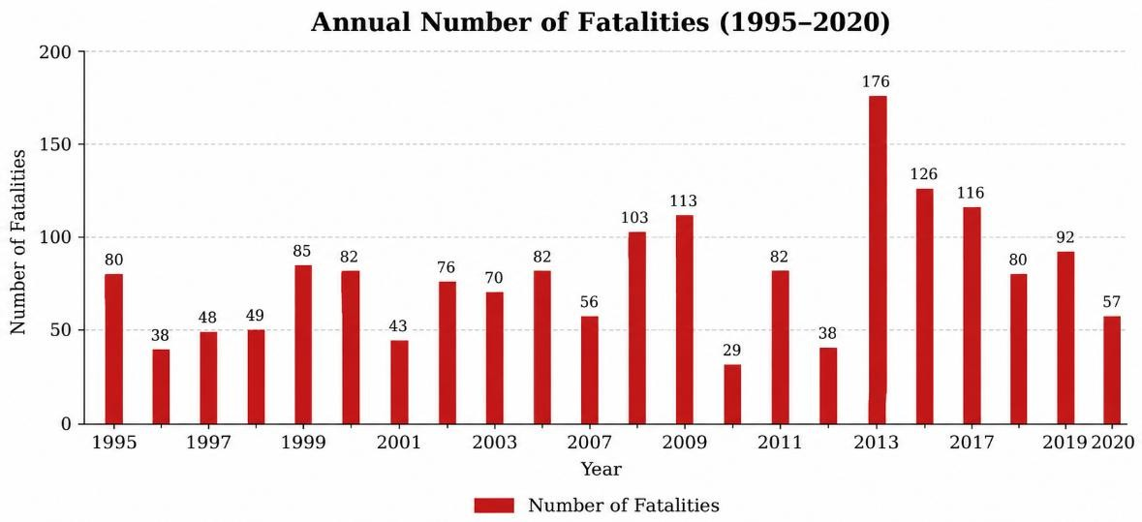
Figure 6. Annual Flood-Related Fatalities in the United States [124]
Hurricanes
In the US, most hurricane induced outages are due to transmission line overloads and physical equipment damages, not generation capacity. A Markov tree approach has been developed that allows the assessment of cascading outage risks under hurricane loading conditions [69]. Dynamic weather forecast influenced sequential Markov chain-based preventative dispatching has the potential to minimize impact of storms on the transmission system [70]. Hurricane Sandy had also demonstrated the potential for cross-infrastructure cascading effects, by creating natural gas distribution outages to approximately 32,000 customers in New Jersey [71]. Monte Carlo simulations of microgrids in hurricane scenarios also demonstrated increased benefit from higher penetration of wind and solar energy [72]. Protecting vital loads during prolonged blackout situations by pre-event resource coordinating was a commonly cited mitigation measure [73,74]. Figure 7 compares the adjusted economic damages caused by the costliest hurricanes affecting the United States, highlighting the severe financial consequences of major storm events and the importance of resilient grid design and emergency preparedness.
3) Wildfires
Rising ambient temperature and increased heating on the conductors is becoming an increasing risk for energy infrastructure from wildfire events, a good example is the destruction of the world's largest geothermal power plant during the 2015 wildfire season in California [75]. Causes of wildires are lightning, volcanic eruptions or human action, while the duration of a wildfire is one of the most significant factors influencing damage to infrastructure and the environment [76]. Ignition sources on the infrastructure side typically include transformers catching fire from oil immersion, defective conductors or aging equipment [77]. In order to prevent wildfire-induced outages, replacing oil-immersed transformers by dry-type ones have been investigated [78]. Probability models link wildfire phenomena to line aging and failures [79], and hazard analysis techniques map relationships between wildfire incidents and line events [80]. Establishing resilient, and totally independent, power supply and grid components have been identified as the main defense in the long term [81]. Radiative heat flux and solar irradiance have been used in conjunction with spreading rates of wildfires as data in the simulation of wildfire propagation to assess and design grid hardening [82].
Figure 7. Hurricane-related Damages in the United States [125]
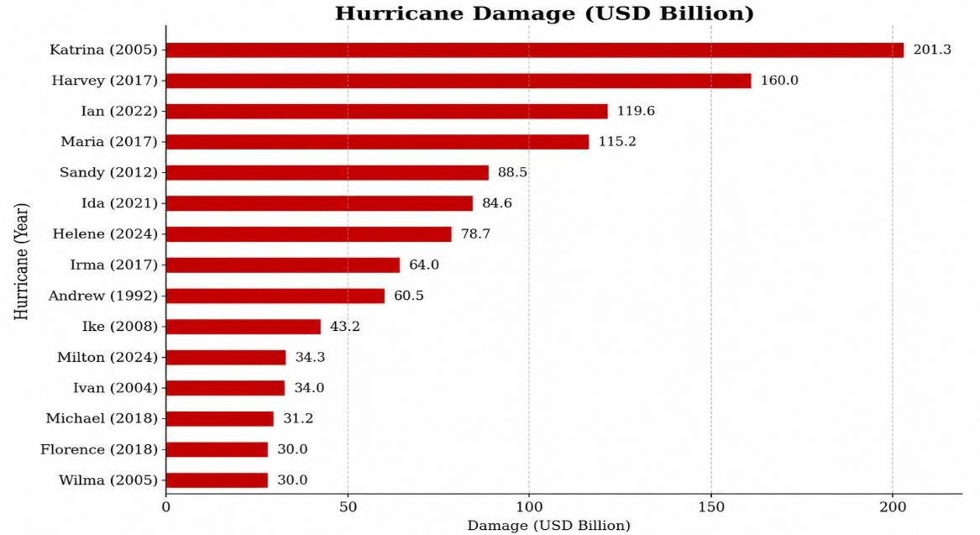

Earthquakes
Ground motion from earthquakes poses a major hazard to storage and distribution equipment and is a classic HILP. A general vulnerability assessment framework for power systems under seismic loads along with a variety of mitigation methods has been presented [83]. There are separate earthquake-resilient distribution system frameworks [84] and a two-stage stochastic optimization model which determine the most robust network upgrades [85]. Figure 8 presents selected storm-related damage costs in the United States based on adjusted economic loss values, providing a comparative view of major high-impact events and emphasizing the broader resilience challenges posed by extreme weather.
Figure 8. Selected storm-related damages in the United States based on adjusted loss estimates. [126].
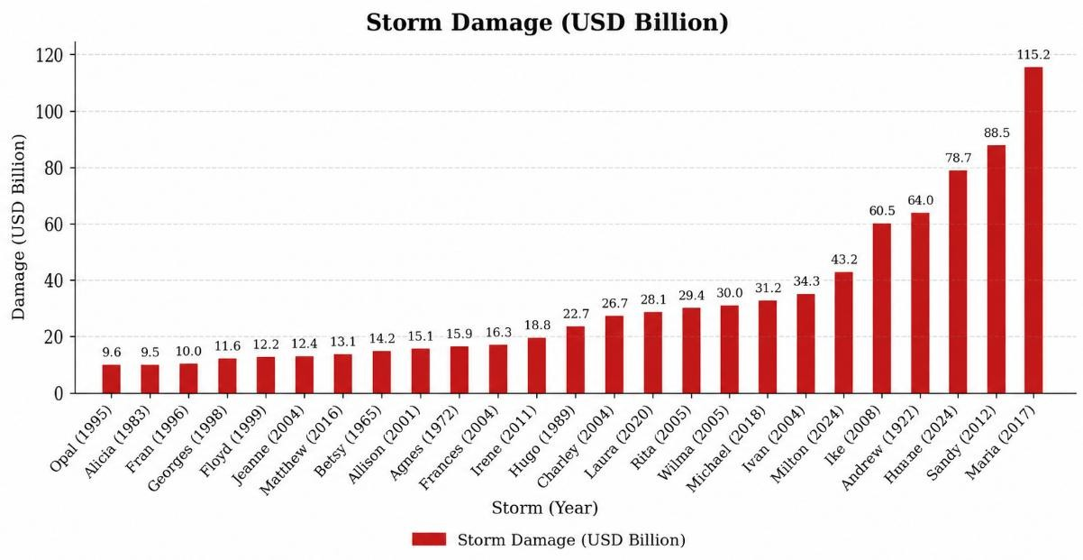
Cyber Threats
False Data Injection (FDI) Attacks
FDI attacks are insertion of false measurements and/or false control signals into the SG communications to compromise state estimation and consequently the control maneuvers driven by the estimated states. This can lead to various issues ranging from unnecessary load shedding to physical damages to blackouts over a wide area. The principal countermeasures proposed are illustrated in Figure 9.

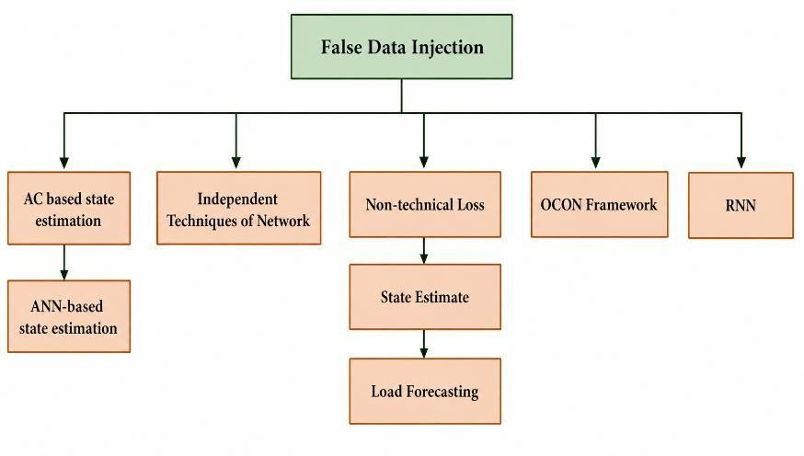
Figure 9. Proposed Solutions for Mitigating False Data Injection Attacks in Smart Grids.
• AC-Based State Estimation
The weaknesses of FDI in AC state estimation have been thoroughly investigated. A semidefinite programming (SDP) convexification framework was presented in [86] that can determine possible attack areas with respect to both the measurement configuration and the grid structure. Validation in IEEE 30-bus and 118-bus systems show a robust behavior to noise and measurement error [87].
• ANN-Based State Estimation
The ANN estimator is considerably quicker compared to iterative classical methods. However, ANN estimators are vulnerable to adversarial attack. Gradient-based (SLSQP) and population-based (Differential Evolution) algorithms have both been demonstrated to generate attack vectors against ANN estimators [88] implying the need to use adversarial training when creating ANN-based state estimators.
• Network Topology-Based FDI Detection
Communication network corruption leads to unwanted trips and load sheds. Three network topology-based FDI detection techniques have been implemented; FDILR (linear regression), FDILRT (time-stamped linear regression), and FDIDT (delta thresholds).FDILRT generally performs better than FDILR; however, FDIDT causes attacks to remain undetected [40]. Algorithms used to forecast data may be used to reconstruct missing values in order to develop the attack matrix.
• Machine learning based approaches; NTL, SE, load forecasting
Non-technical losses: A combination of SVM classifiers, voltage estimation and system optimization has been introduced [89]. Clustering is commonly applied [90], but it generally under-performs more advanced manipulative-profile approaches [91]. Strong performance has been achieved using XGboost, LightGBM and CatBoost models [92][93] this was verified further on state grid data [94]. State Estimation- An exhaustive analysis of supervised ML and heuristic feature selection has been implemented [95]. Distributed deep autoencoder frameworks [96] and POMDP-based reinforcement learning [97] were found to be useful, accuracy is also increased with integration of real measurement data [98].
Load Forecasting: Models range from pure accuracy-oriented designs [99] to those incorporating MLAD [100] and deep learning defense layers [101]. Attack vulnerability studies [102] have driven development of neural-network [103] and game-theoretic [104] defensive frameworks.
• ELM-Based OCON Framework
The OCON framework uses ELM algorithms within identification layers to precisely locate bus-level FDI attacks and recover corrupted values.
RNN-Based Detection
RNNs exploit temporal patterns in sequential measurement data. Simulations on IEEE-30 bus system data for five years have verified that RNNs can capture the temporal and spatial correlations between measurements, which significantly improves the detection accuracy compared with traditional approaches [47].
• CAD Framework
A compact detection framework using cosine similarity coefficients (CSC) and Spearman rank-order correlation has been proposed for SG cybersecurity [6]. RTDS case studies showed that it identifies attack onset within half a cycle, maintains performance under noise, and does not require predefined detection thresholds.
DDoS Attacks
The two-way communication architecture of modern SGs is directly exploitable by DDoS attacks. Flooding the network with spurious connection requests and data packets overwhelms database servers and other critical nodes, denying service to legitimate users. Table 3 records selected real-world attacks for reference.

Table 3. Real-life examples of attacks
Attack | Scope | Year
Kaseya Ransomware | 800–1500 companies | July 2021
SolarWinds Supply Chain | 500+ orgs incl. US military/federal agencies | Dec 2020
Amazon DDoS | 2.3 Tbps attack volume | Feb 2020
Twitter Celebrities Hack | 130 high-profile accounts | July 2020
• Multilevel Autoencoder-Based Feature Learning
An unsupervised DDoS detection approach using a shallow autoencoder and a deep autoencoder to generate feature representations that are combined by MKL algorithms to build a robust detection model [57].
• DoS Attack Detection
PCA is used for feature reduction and SVM for classification, for a real-time server-to-meter communication monitoring using an ML model with high accuracy in identifying DoS attacks [56].
• Honeypots
Honeypots in AMI networks capture attack data and characterize adversarial behavior. Attacker-defender interaction analysis can then be used to derive optimal defensive responses. Theoretical work confirms the existence of multiple Bayesian-Nash equilibria in these scenarios [105].
3) Electricity Theft
• Dynamic Detection Using ToU Pricing
Dynamic pricing models such as time-of-use (ToU) tariffs are expected to be common [106]. ToU divides the day into periods of higher or lower probability of theft according to price differentials, thereby creating natural detection windows.
• Ensemble Machine Learning
Ensemble Machine Learning AMI’s bi-directional architecture provides opportunities for energy theft. Ensemble ML models mitigate this by combining multiple algorithmic outputs to reduce variance and bias. On Energy Regulatory Commission data, Extra Trees and RF bagging reached AUC 0.90; boosting achieved 0.80 for individual samples. Bagging methods showed the best precision for real-time application [52].
• RSA-Based Detection
An RSA cryptographic method creates two distinct cryptograms from each measurement before transmission; the receiving end cross-compares them to detect tampering [107].
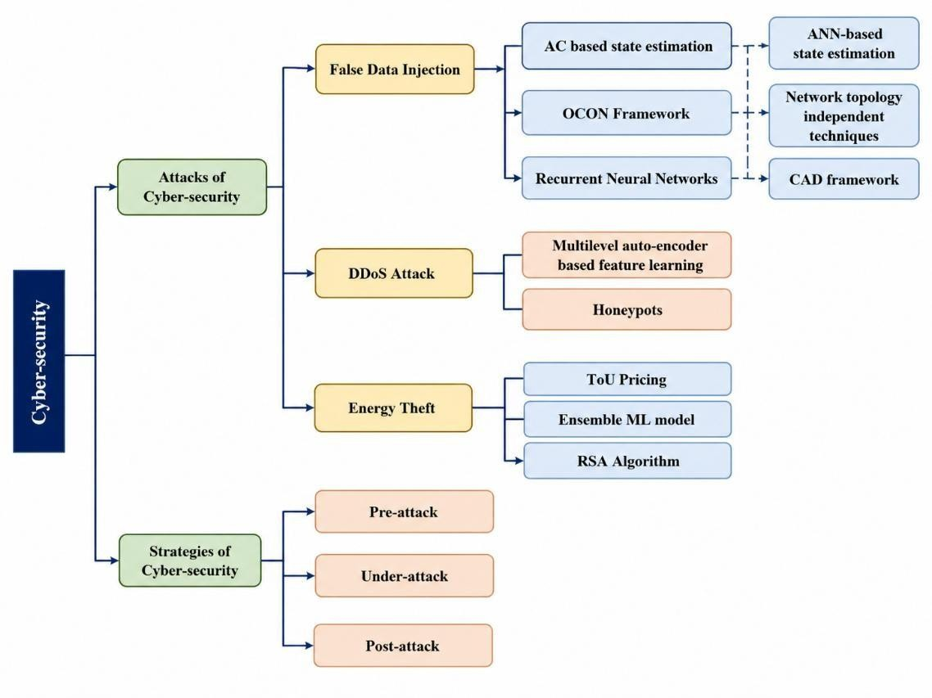
Figure 10. Overview of Cyber-Security Attack Types and Corresponding Mitigation Strategies in Smart Grids.
Cyber Security Strategies
Proposed countermeasures span a broad range of architectures and threat models. Single-vector solutions are common in the literature, but comprehensive frameworks aim to cover the grid as a whole. Figure 10 maps these strategies across three operational phases.
1) Pre-Attack Phase
Before an attack, the focus is on hardening: device security, network-level defenses, and cryptographic controls. Authentication, encryption, compliance verification, and key management are the core tools. A 2025 study suggested a BLAKE3-based dynamic key rotation mechanism and intrusion detection for smart grid ICS communication, for low-overhead and resilient cryptographic protection [120]. Figure 11 illustrates representative solutions for this phase.
Figure 11. Key Security Solutions Applied in the Pre-Attack Phase of Smart Grid Defense [24], [120].
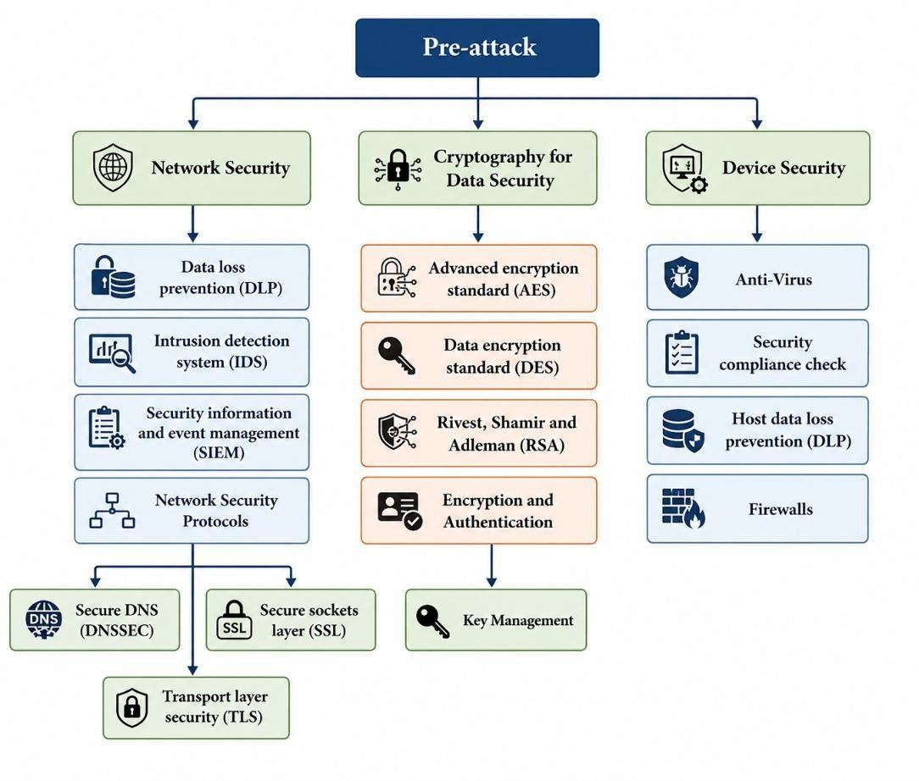
Under Attack Phase
During an active intrusion, detection and containment take priority. IDS platforms, SIEM systems, and DLP tools form the primary response layer. None of these is static—as attack methods evolve, so must the defense tools.
Post-Attack Phase
Post-incident work is most important for sophisticated persistent threats such as Stuxnet, which can operate undetected for long periods of time. Recovery means updating firmware, refreshing IDS signatures and antivirus definitions, revising access policies and conducting forensic reconstruction of the attack timeline to close the exploited vulnerabilities.
Methods for Resilience Assessment
1) Bayesian Network Approach
Bayesian networks are directed acyclic graphs where the nodes are variables and the edges represent the conditional dependence between the variables [22]. They are one possible formalism for determining the risk and resilience of systems subject to uncertainty. Both probabilistic inference and sensitivity analysis allows analysts to evaluate levels of vulnerability and compare different strategies for resilience without recourse to deterministic system models.
2) Qualitative and Quantitative Methods
Qualitative methods have been widely used in system component identification and mapping of interdependencies, along with structured evaluation frameworks. In many cases, these analyses extend beyond the electrical system to the domains of IT networks, fuel supply chains and other interdependent infrastructures. Priority inputs include; availability of repair resources; the level of training of workforces; level of emergency preparedness. Conventional tools include; indicators that are primarily qualitative or semi-quantitative; conceptual frameworks based on key dimensions of resilience, namely fault diagnosis, robustness, impact prevention, and adaptability [108][109].
Cross-disciplinary evaluation has utilized various forms of concept, such as complementarity, diversity, redundancy, structural robustness and governance. For cyber-physical systems, resilience in electrical power systems means that there is continuous power provision under an order-based prioritization of load, with ongoing adjustment of topology and distribution of resources as conditions vary [110][111]. At the city-level, concepts analogous to these dimensions of resilience for power systems has been outlined in urban energy system resilience frameworks [23].
3) Quantitative Resilience Assessment
Quantitative methods are preferred when before-and-after comparisons are needed or when different system configurations must be ranked. They use formal performance quantification rather than descriptive frameworks.
The starting point is a Figure of Merit (FOM)—a parameter capturing the quantity and quality of services delivered. For a power system under disturbance, resilience R compares targeted functional output F₀(t) with actual output F(t) over the event duration [9][65]:
𝑡4
𝑅 = ∫ [𝐹₀(𝑡) − 𝐹(𝑡)] 𝑑𝑡 (1)
𝑡1
System reconfiguration is considered to facilitate load restoration. Two integer decision variables are adopted:
a. Let 𝑧𝑖𝑗 = 1 if the 𝑖𝑗 line is sealed; otherwise, 𝑧𝑖𝑗 = 0.
b. 𝛾, 𝛾𝑘 = 1 if the 𝑘-th potential root bus is selected as the root bus; otherwise, 𝛾𝑘 = 0. At bus 𝑗, 𝑤𝑗 indicates the priority weight.
c. The objective function is defined to maximize the prioritized load based on total weight:
max ∑ 𝑤_{𝑗} 𝑃_{𝐿,𝑗} (2)
𝑗∈𝐵
With respect to power flow from bus 𝑖 to bus 𝑗 for each line (𝑖, 𝑗), let 𝐻𝑖𝑗 and 𝐺𝑖𝑗 denote the active and reactive power flows at the sending end, respectively. At the receiving end, these flows are expressed as:
Active:− (𝐻_{𝑖𝑗} − 𝑟_{𝑖𝑗} 𝑙_{𝑖𝑗}), Reactive: − (𝐺_{𝑖𝑗} − 𝑥_{𝑖𝑗} 𝑙_{𝑖𝑗} ) (3)
If the branch is closed, the voltage difference across it is constrained by the current, and the branch current must be within limits. Conversely, if the branch is open, the voltage difference is unconstrained, and no power flow occurs.
The power flow limits are expressed by:
𝐻2 + 𝐺2 = 𝑙_{𝑖𝑗} 𝑢_{𝑖}, ∀(𝑖, 𝑗) ∈ 𝐸 (4)
𝑖𝑗 𝑖𝑗
Equation represents a nonlinear, non-convex quadratic equality constraint. To overcome computational challenges in mixed-integer nonlinear programming, a relaxed conic formulation is used, transforming the quadratic equality into an inequality:
𝐻2 + 𝐺2 ≤ 𝑙𝑖𝑗 𝑢𝑖, ∀(𝑖, 𝑗) ∈ 𝐸 (5)
Restoration Methods and Strategies
1) DG Islandin
One of the more useful features of intelligent power systems is the ability to detect outages and automatically reroute power around fault zones. By deliberately forming islands in the transmission network, faults can be isolated before they cascade. An algorithm is developed to guide the recovery of non-black-start generators and critical loads with electrical betweenness as a prioritization metric.
Distribution restoration includes load redistribution and network reconfiguration, as well as coordination of voltage regulators, capacitor banks, and DERs. The islanding capability provides resilience by creating microgrids and constraining the geographic scope of disruptions resulting from disasters.
A linearized dist.-flow model with a single-commodity flow technique—which preserves radial topology—has been developed for this purpose [85].
2) Plug-In Hybrid Electric Vehicles (PHEVs)
Restoring overhead distribution after a major blackout is slow. PHEVs can serve as fast-deployable distributed energy sources that help balance supply and demand in the interim. Even at penetration below 2%, they can increase available energy by roughly 25%; at higher penetration levels the contribution grows substantially, with measurable effects on resilience metrics [75].
Energy Management Systems (EMS)
While distribution topology changes are uncommon in normal operation, EMS platforms can substantially improve post-event performance. EMS uses the combination of demand response, microgrids, storage and EVs for continues operation. Either central or distributed schemes can be found. One MPC-based EMS has been successfully applied on distributed microgrid management, and has improved the decrease of emergency shedding and reduced uncertainty from components' outages [91].
Microgrids
Microgrids can operate in a grid-connected mode or an islanded mode. They provide black-start and restoration capabilities in the grid-connected mode. When in the islanded mode, and more specifically when the grid is experiencing an HILP, the microgrid provides these loads-hospitals, data centers, universities-from local generation and storage, rather than being subject to the voltage instability and frequency issues that would occur if it were tied to an ailing main grid.
Defensive Islanding
Defense islanding is an algorithm for segmentation of the grid and can minimize damage of large-scale failures by ensuring service for the critical areas is kept. It differs from traditional islanding in that segment’s borders are predetermined based on expected threat, and not predetermined by fault.

Conclusion
In this review, we analyzed the resilience and cyber-security of smart grids from three different viewpoints: the threat context (natural or cyber), the framework used for definition and measurement of resilience, and the defense strategies (primarily ML-based) which have been deployed or proposed. FDI attacks were emphasized more since it is evident, they are capable of damaging the whole grid.
The literature strongly suggests ML methods (mainly RNNs and Ensemble methods) achieve good performance in detecting anomalies and adaptation. They do it because they are capable of exploring both spatial and temporal data patterns while rule-based methods are unable to. In this scope, distributed DL techniques, especially a combination of federated learning schemes and Transformer models are thought as a good research line to tackle all detection accuracy, data privacy and communication overhead issues simultaneously in distributed smart grid [117]. Nevertheless, the literature is not that precise on how to bring the results from the lab to production systems. Real life issues like the processing constraint at real time, bad data quality, huge size of the grid to be scaled and Lack of common metrics for resilience are still present. Future research lines could also consider the hybrid and interpretable AI approaches as well as well-defined benchmark for resilience and ML based detections being closely tied to the control operation of the smart grid. The concept of integrating ML to SG architecture is very attractive, and results so far are good, but the actual path to large scale systems is not that clear yet.

References

[1] A. I. Kawoosa and D. Prashar, "A review of cyber securities in smart grid technology," in Proc. ICCAKM, 2021.
[2] B. Chen, J. Wang, and M. Shahidehpour, "Cyber-physical perspective on smart grid design and operation," IEEE Electrification Mag., vol. 3, no. 3, pp. 129–141, 2018.
[3] G. Dileep, "A survey on smart grid technologies and applications," Renew. Energy, vol. 146, pp. 2589–2625, 2020.
[4] A. O. Otuoze, M. W. Mustafa, and R. M. Larik, "Smart grids security challenges: Classification by sources of threats," J. Electr. Syst. Inf. Technol., vol. 5, no. 3, pp. 468–483, 2018.
[5] B. B. Gupta and T. Akhtar, "A survey on smart power grid: Frameworks, tools, security issues, and solutions," Ann. Telecommun., vol. 72, no. 9, pp. 517–549, 2017.
[6] S. De and R. Sodhi, "A simple cyber attack detection scheme for smart grid," in Proc. NPSC, 2020, pp. 1–6.
[7] S. Aoufi, A. Derhab, and M. Guerroumi, "Survey of false data injection in smart power grid," J. Inf. Secur. Appl., vol. 54, p. 102518, 2020.
[8] J. Jiang and Y. Qian, "Defense mechanisms against data injection attacks in smart grid networks," IEEE Commun. Mag., vol. 55, no. 10, pp. 76–82, 2017.
[9] Amanlou et al., "Cybersecurity challenges in smart grid systems," IEEE Open J. Commun. Soc., 2025.
[10] S. S. Ullah et al., "Measurable challenges in smart grid cybersecurity enhancement," in Proc. IEEE GreenTech, 2021, pp. 331–338.
[11] L. Das et al., "Measuring smart grid resilience: Methods, challenges and opportunities," Renew. Sustain. Energy Rev., vol. 130, p. 109918, 2020.
[12] Z. Wang and J. Wang, "A delay-adaptive control scheme for enhancing smart grid stability and resilience," Int. J. Electr. Power Energy Syst., vol. 110, pp. 477–486, 2019.
[13] M. Ayar et al., "A distributed control approach for enhancing smart grid transient stability and resilience," IEEE Trans. Smart Grid, vol. 8, no. 6, pp. 3035–3044, 2017.
[14] Y. Lin, Z. Bie, and A. Qiu, "A review of key strategies in realizing power system resilience," Global Energy Interconnection, vol. 1, no. 1, pp. 70–78, 2018.
[15] J. Xie et al., "A review of machine learning applications in power system resilience," in Proc. IEEE PESGM, 2020, pp. 1–5.
[16] M. Mahzarnia et al., "A review of the measures to enhance power systems resilience," IEEE Syst. J., vol. 14, no. 3, pp. 4059–4070, 2020.
[17] A. Farraj, E. Hammad, and D. Kundur, "Storage-based multi-agent regulation for smart grid resilience," IEEE Trans. Ind. Informat., vol. 14, no. 9, pp. 3859–3869, 2018.
[18] A. Dehghani et al., "Overview of resilience assessment metrics in electrical grids," Int. Trans. Electr. Energy Syst., vol. 31, no. 12, p. e13159, 2021.

[19] A. Y. Fard et al., "Cyberattack resilient control for power electronics dominated grid," in Proc. IEEE PEDG, 2021, pp. 1–6.
[20] G. Bai et al., "Improved resilience measure for component recovery priority in power grids," Front. Eng. Manag., pp. 1–12, 2021.
[21] G. Huang et al., "Integration of preventive and emergency responses for power grid resilience enhancement," IEEE Trans. Power Syst., vol. 32, no. 6, pp. 4451–4463, 2017.
[22] N. U. Ibne Hossain et al., "Modeling and assessing cyber resilience of smart grid using Bayesian network," J. Comput. Des. Eng., vol. 7, no. 3, pp. 352–366, 2020.
[23] T. H. M. I. A.-K. Fadhil and L. A. A. Al-Hafidh, "Legal and communication challenges in SG cybersecurity," J. Commun., vol. 20, no. 2, 2025.
[24] G. Bedi et al., "Review of IoT in electric power and energy systems," IEEE Internet Things J., vol. 5, no. 2, pp. 847–870, 2018.
[25] T. S. Ustun et al., "AI-based intrusion detection for IEC 61850 sampled values," IEEE Access, vol. 9, pp. 56486–56495, 2021.
[26] T. S. Ustun et al., "ML-based intrusion detection using IEC 61850 GOOSE messages," Symmetry, vol. 13, no. 5, p. 826, 2021.
[27] Y. Zhang and J. Yan, "Semi-supervised domain-adversarial training for intrusion detection in SG," in Proc. IJCNN, 2020.
[28] A. D. Syrmakesis and N. D. H. Dervos, "Cyber resilience methods for smart grids against FDI attacks," Front. Smart Grids, vol. 3, p. 1397380, 2024.
[29] S. M. Taghavinejad et al., "Intrusion detection in IoT-based SG using hybrid decision tree," in Proc. ICWR, IEEE, 2020.
[30] S. Khan et al., "Intelligent intrusion detection in smart grid using computational intelligence," Trans. Emerg. Telecommun. Technol., vol. 32, no. 6, p. e4062, 2021.
[31] D. D. Roy and D. Shin, "Network intrusion detection in smart grids for imbalanced attack types," in Proc. ICTC, IEEE, 2019, pp. 576–581.
[32] G. Prasad et al., "ML-based physical-layer intrusion detection for the smart grid," in Proc. SmartGridComm, IEEE, 2019, pp. 1–6.
[33] A. Subasi et al., "Intrusion detection in smart grid using bagging ensemble classifiers," in Proc. ISGT-Europe, IEEE, 2019, pp. 1–5.
[34] D. A. Chekired et al., "Fog-based distributed IDS against false metering attacks in SG," in Proc. ICC, IEEE, 2019, pp. 1–6.
[35] R. T. Ibrahim and Z. T. Mohammed, "Training RNNs by hybrid PSO-cuckoo search," Int. J. Comput. Appl., vol. 159, no. 3, pp. 32–38, 2017.
[36] L. Haghnegahdar and Y. Wang, "WOA-trained ANN for smart grid cyber intrusion detection," Neural Comput. Appl., vol. 32, no. 13,
pp. 9427–9441, 2020.
[37] Y. Li et al., "Intrusion detection using OS-ELM in AMI of smart grid," PLOS ONE, vol. 13, no. 2, p. e0192216, 2018.
[38] R. Vijayanand et al., "SVM-based IDS with reduced features for AMI of smart grid," in Proc. ICACCS, IEEE, 2017, pp. 1–7.
[39] P. Radoglou Grammatikis et al., "ARIES: A multivariate IDS for smart grid," Sensors, p. 5305, 2018.
[40] R. Nawaz et al., "ML-based false data injection in smart grid," Int. J. Electr. Power Energy Syst., vol. 130, p. 106819, 2021.
[41] M. Mohammadpourfard et al., "Cybersecurity of SG against data integrity attacks under concept drift," Int. J. Electr. Power Energy Syst., vol. 119, p. 10594, 2020.
[42] M. Ashrafuzzaman et al., "Detecting stealthy FDI attacks using ensemble ML," Comput. Secur., vol. 97, p. 101994, 2020.
[43] D. Yao et al., "Energy theft detection with privacy preservation in SG," IEEE Internet Things J., vol. 6, no. 5, pp. 7659–7669, 2019.
[44] T. Hu et al., "Semisupervised deep learning for electricity fraud detection in AMI," IEEE Trans. Neural Netw. Learn. Syst., vol. 30, no. 11, pp. 3287–3299, 2019.
[45] J. Sakhnini et al., "Smart grid cyber attacks detection using supervised learning," in Proc. SEGE, IEEE, 2019, pp. 108–112.
[46] S. Ahmed et al., "Unsupervised detection of covert data integrity attacks using Isolation Forest," IEEE Trans. Inf. Forensics Secur., vol. 14, no. 10, pp. 2765–2777, 2019.
[47] A. Ayad et al., "Detection of FDI attacks in smart grids using RNNs," in Proc. IEEE ISGT, 2018, pp. 1–5.
[48] D. Xue et al., "FDI detection in SG using ELM-based OCON framework," IEEE Access, vol. 7, pp. 31762–31773, 2019.
[49] L. Yang et al., "Improved-ELM for detecting false data attack in smart grid," Int. J. Electr. Power Energy Syst., vol. 91, pp. 183–191, 2017.
[50] S. Wang et al., "Locational detection of FDI attacks: A multi-label classification approach," IEEE Internet Things J., vol. 7, no. 9, pp. 8218–8227, 2020.
[51] S. O. Tehrani et al., "Decision tree based electricity theft detection in SG," in Proc. SCIOT, IEEE, 2020.
[52] S. K. Gunturi and D. Sarkar, "Ensemble ML for energy theft detection," Electr. Power Syst. Res., vol. 192, p. 106904, 2021.
[53] M. Adil et al., "Electricity theft detection using ML techniques," in Proc. CISIS, Springer, 2020, pp. 233–243.
[54] M. Panthi, "Anomaly detection in smart grids using ML," in Proc. ICPC2T, IEEE, 2020.
[55] P. I. Radoglou-Grammatikis and P. G. Sarigiannidis, "CART-based anomaly IDS for smart grid," in Proc. GIIS, IEEE, 2018, pp. 1–5.
[56] W. Zhe et al., "DoS attack detection in SG using ML," in Proc. ICPICS, IEEE, 2020.
[57] S. Ali and Y. Li, "Multilevel auto-encoders for DDoS detection in SG," IEEE Access, vol. 7, pp. 108647–108659, 2019.
[58] Y. A. Farrukh et al., "Sequential supervised ML for cyber attack detection in SG," in Proc. NAPS, IEEE, 2021, pp. 1–6.
[59] M. Izadi et al., "Critical review on definitions and indices in resiliency-oriented power systems," Int. Trans. Electr. Energy Syst., vol. 31, no. 1, p. e12680, 2021.
[60] A. Humayed et al., "Cyber-physical systems security: A survey," IEEE Internet Things J., vol. 4, no. 6, pp. 1802–1831, 2017.

[61] B. Pradhan et al., "Semiautomated flood detection from TerraSAR-X using Taguchi optimization," IEEE Trans. Geosci. Remote Sens., vol. 54, no. 7, pp. 4331–4340, 2016.
[62] L. Pulvirenti et al., "SAR data for floodwater detection in urban/agricultural areas," IEEE Trans. Geosci. Remote Sens., vol. 54, no. 3,
pp. 1532–1544, 2015.
[63] M. Panteli et al., "Metrics and quantification of operational and infrastructure resilience," IEEE Trans. Power Syst., vol. 32, no. 6, pp. 4732–4742, 2017.
[64] M. H. Amirioun et al., "Proactive microgrid scheduling against extreme floods," IEEE Trans. Smart Grid, vol. 9, no. 4, pp. 3900–3902, 2017.
[65] A. K. Cutrell et al., "HAZUS flood model FEMA SOP for Level 2 analysis," FEMA, Washington, DC, USA, 2018.
[66] M. H. Amirioun et al., "Proactive microgrid scheduling against extreme floods," IEEE Trans. Smart Grid, vol. 9, no. 4, pp. 3900–3902, 2018.
[67] W. Yuan et al., "Robust optimization for resilient distribution network planning," IEEE Trans. Smart Grid, vol. 7, no. 6, pp. 2817–2826, 2016.
[68] S. Ma et al., "Resilience enhancement of distribution grids against extreme weather," IEEE Trans. Power Syst., vol. 33, no. 5, pp. 4842–4853, 2018.
[69] R. Yao et al., "Risk assessment of cascading outages via Markovian tree search," IEEE Trans. Power Syst., vol. 32, no. 4, pp. 2887–2900, 2016.
[70] C. Wang et al., "Resilience enhancement with sequentially proactive strategies," IEEE Trans. Power Syst., vol. 32, no. 4, pp. 2847–2857, 2016.
[71] C. He et al., "Robust hardening for integrated electricity and gas distribution systems," IEEE Trans. Power Syst., vol. 33, no. 5, pp. 5787–5798, 2018.
[72] E. B. Watson and A. H. Etemadi, "Grid resilience modelling under hurricane conditions with solar/wind generation," IEEE Trans. Power Syst., vol. 35, no. 2, pp. 929–937, 2019.
[73] M. H. Amirioun et al., "Resilience-oriented scheduling against hurricanes in multi-energy microgrids," IEEE Trans. Power Syst., vol. 34, no. 3, pp. 2160–2168, 2018.
[74] Y. Wang et al., "Coordinated service restoration from multiple sources," IEEE Trans. Smart Grid, vol. 10, no. 5, pp. 5781–5793, 2019.
[75] M. Waseem and S. D. Manshadi, "Electricity grid resilience amid natural disasters," Electr. J., vol. 33, no. 10, p. 106864, 2020.
[76] S. Jazebi et al., "Wildfire management review – Part I," IEEE Trans. Power Del., vol. 35, no. 1, pp. 430–439, 2019.
[77] H. Lu et al., "Smart load management of toroidal transformers using dynamic thermal model," IET Gener. Transm. Distrib., vol. 12, no. 1, pp. 142–149, 2018.
[78] Y. Guo et al., "Transmission line ageing failure probability from forest fire impact," IET Gener. Transm. Distrib., vol. 12, no. 16, pp. 3812–3819, 2018.
[79] J. Lu et al., "Risk analysis of grid faults under wildfire disasters," Int. Trans. Electr. Energy Syst., vol. 29, no. 9, p. e12055, 2019.
[80] S. Jazebi et al., "Wildfire management review – Part II," IEEE Trans. Power Del., vol. 35, no. 1, pp. 440–450, 2019.
[81] N. Bhusal et al., "Modeling natural disasters for power system resilience," in Proc. PMAPS, IEEE, 2020, pp. 1–6.
[82] M. Nazemi and P. Dehghanian, "Seismic-resilient bulk power grids: Modeling and mitigation," IEEE Trans. Eng. Manag., vol. 67, no. 3, pp. 614–630, 2019.
[83] M. Nazemi et al., "Energy storage planning for earthquake resilience in distribution networks," IEEE Trans. Sustain. Energy, vol. 11, no. 2, pp. 795–806, 2019.
[84] T. Lagos et al., "Optimal resilient network investments against natural hazards," IEEE Trans. Power Syst., vol. 35, no. 2, pp. 1411–1421, 2019.
[85] M. Jin et al., "AC-based power grid state estimation: Vulnerability under cyber attacks," IEEE Trans. Autom. Control, vol. 64, no. 5,
pp. 1784–1799, 2018.
[86] J. Zhao et al., "Generalized FDI attacks against nonlinear state estimator and countermeasures," IEEE Trans. Power Syst., vol. 33, no. 5, pp. 4868–4877, 2018.
[87] T. Liu and T. Shu, "Security of ANN-based AC state estimation in smart grid," Comput. Secur., vol. 105, p. 102265, 2021.
[88] K. Zheng et al., "Electricity theft detection via density-clustering," in Proc. ISGT-Asia, IEEE, 2017, pp. 1–6.
[89] K. Zheng et al., "Combined data-driven approach for electricity theft detection," IEEE Trans. Ind. Informat., vol. 15, no. 3, pp. 1809–1819, 2018.
[90] M. M. Buzau et al., "Non-technical losses detection using smart meter data and supervised learning," IEEE Trans. Smart Grid, vol. 10, no. 3, pp. 2661–2670, 2018.
[91] R. Punmiya and S. Choe, "Energy theft detection using gradient boosting with feature engineering," IEEE Trans. Smart Grid, vol. 10, no. 2, pp. 2326–2329, 2019.
[92] Z. Zheng et al., "Wide and deep CNNs for electricity-theft detection," IEEE Trans. Ind. Informat., vol. 14, no. 4, pp. 1606–1615, 2017.
[93] M. Zhou et al., "Ensemble-based synchrophasor data anomaly detection," IEEE Trans. Smart Grid, vol. 10, no. 3, pp. 2979–2988, 2018.
[94] J. Wang et al., "Distributed deep autoencoder framework for PMU data manipulation detection," IEEE Trans. Smart Grid, vol. 10, no. 4, pp. 4401–4410, 2018.

[95] Y. Chen et al., "Reinforcement learning-based FDI attack evaluation for voltage control," IEEE Trans. Smart Grid, vol. 10, no. 2, pp. 2158–2169, 2018.
[96] Y. Li et al., "GAN-based measurement recovery under FDI attacks," IEEE Trans. Ind. Informat., vol. 16, no. 3, pp. 2031–2043, 2019.
[97] Y. Liang et al., "Poisoning attack on load forecasting," in Proc. ISGT Asia, IEEE, 2019, pp. 1230–1235.
[98] M. Cui et al., "ML-based anomaly detection for load forecasting under cyberattacks," IEEE Trans. Smart Grid, vol. 10, no. 5, pp. 5724–5734, 2019.
[99] Y. Chen et al., "Adversarial attacks exploiting load forecasting vulnerabilities," in Proc. ACM e-Energy, Jun. 2019.
[100] C. Barreto and X. Koutsoukos, "Cyber-resilient load forecast system design," in Proc. GameSec, Springer, 2019.
[101] L. Cui et al., "Detecting false data attacks using ML in smart grid: A survey," J. Netw. Comput. Appl., p. 102808, 2020.
[102] K. Wang et al., "Strategic honeypot game model for DDoS in smart grid," IEEE Trans. Smart Grid, vol. 8, no. 5, pp. 2474–2482, 2017.
[103] R. Punmiya and S. Choe, "ToU-based dynamic theft detection using gradient boosting," Appl. Sci., vol. 11, no. 1, p. 401, 2021.
[104] N. Khelifi, "Cryptographic approach for electricity theft detection in SG," Comput. Mater. Continua, vol. 63, no. 1, pp. 97–117, 2020.
[105] S. Hosseini et al., "Definitions and measures of system resilience: A review," Reliab. Eng. Syst. Saf., vol. 145, pp. 47–61, 2016.
[106] A. S. Kahnamouei et al., "Conceptual resilience framework for electrical power systems," in Proc. IET RTDN, 2017, pp. 1–11.
[107] A. S. Kahnamouei et al., "Measuring resilience in energy systems across disciplines," in Proc. IET RTDN, 2017, pp. 1–11.
[108] R. Arghandeh et al., "On the definition of cyber-physical resilience in power systems," Renew. Sustain. Energy Rev., vol. 58, pp. 1060–1069, 2016.
[109] A. Sharifi and Y. Yamagata, "Conceptual framework for urban energy resilience assessment," Energy Procedia, vol. 75, pp. 2904–2909, 2015.
[110] Z. Bie et al., "Battling the extreme: Power system resilience study," Proc. IEEE, vol. 105, no. 7, pp. 1253–1266, 2017.
[111] B. Lipa et al., "Evaluating HF coastal radar for tsunami warning," Remote Sens., vol. 11, no. 23, p. 2773, 2019.
[114] T. H. M. I. A.-K. Fadhil and L. A. A. Al-Hafidh, "Legal and communication challenges in SG cybersecurity: ML-based network resilience classification," J. Commun., vol. 20, no. 2, 2025.
[115] Y. Li, X. Wei, Y. Li, Z. Dong, and M. Shahidehpour, "Detection of false data injection attacks in smart grid: A secure federated deep learning approach," IEEE Trans. Smart Grid, vol. 13, no. 6, pp. 4862–4872, 2022.
[116] M. Faheem, M. Awais, A. Iqbal, and H. Zia, "AI-augmented cybersecurity for smart grids in the United States," World J. Adv. Res. Rev., vol. 27, no. 1, pp. 713–726, 2025.
[117] Verma S. and Rao A., "A short report on deep learning synergy for decentralized smart grid cybersecurity," Front. Artif. Intell., vol. 8, p. 1557960, 2025.
[118] M. A. Aldossary et al., "Detection of disturbances and cyber-attacks in smart grids using explainable machine learning," Sci. Rep., 2025.
[119] K. Deka and S. Vishwanath, "Enhancing smart microgrid resilience under natural disaster conditions: Virtual power plant allocation using the jellyfish search algorithm," Sustainability, vol. 17, no. 3, p. 1043, 2025.
[120] N. S. Dokku et al., "Resilient cybersecurity in smart grid ICS communication using BLAKE3-driven dynamic key rotation and intrusion detection," Sci. Rep., 2025.
[121] H. Zhang, J. Cheng, X. Bai, D. Wang, R. Gao, and B. Fan, "A hierarchical spatio-temporal graph attention network for false data injection attack detection in smart grids," Processes, vol. 14, no. 3, p. 507, 2026.
[122] F. Bibi, S. U. Rehman, S. Bibi, et al., "Reinforcing smart grid resilience through blockchain-supported deep learning models for theft detection," Sci. Rep., vol. 16, p. 10515, 2026.
[123] R. Kumar and M. De, "Advancement in power system resilience through deep reinforcement learning: A comprehensive review," Renew. Sustain. Energy Rev., vol. 222, p. 115951, 2025.
[124] National Weather Service, “Weather Related Fatality and Injury Statistics,” NOAA, [Online]. Available: https://www.weather.gov/hazstat. Accessed: Jun. 15, 2026.
This NOAA/NWS page provides the hazard-fatality statistics by year and explains that the statistics are compiled from Storm Data and made available through NOAA/NCEI’s Storm Events Database.【turn819473view0†L22-L26】
[125] NOAA National Centers for Environmental Information, “U.S. Billion-Dollar Weather and Climate Disasters,” NOAA/NCEI, [Online]. Available: https://www.ncei.noaa.gov/access/billions/. DOI: 10.25921/stkw-7w73. Accessed: Jun. 15, 2026.
The NCEI page provides the official citation for the Billion-Dollar Weather and Climate Disasters dataset and its DOI.【 turn819473view1†L15-L18】
[126] NOAA National Centers for Environmental Information, “Costliest U.S. Tropical Cyclones,” NOAA/NCEI, [Online]. Available: https://www.ncei.noaa.gov/access/billions/dcmi.pdf. Accessed: Jun. 15, 2026.
This NCEI resource lists the adjusted costs for major U.S. tropical cyclones and is suitable as the direct source for the new Fig. 8.【 turn401417search1】

